

|  |  |
| --- | --- |
| Batch details | PGPDSE-FT Offline BLR OCT’22 |
| Team members | Jakati Pavan  Suraj Kumar M  Uppula Dilip Kumar  Pranjal Verma  D Praful |
| Domain of Project | Finance |
| Proposed project title | Credit Score Classification |
| Group Number | 6 |
| Team Leader | Jakati Pavan |
| Mentor Name | Mr. Chandran Venkatesan |

**Table of Contents:**

|  |  |  |
| --- | --- | --- |
| **S. No** | **Topic** | **Page No** |
| **1** | **Project Details** | **4** |
| **2** | **Dataset Information** | **7** |
| **3** | **Data Exploration (EDA)** | **10** |
| **4** | **Base Model** | **38** |
| **5** | **Decision Tree** | **40** |
| **6** | **Random Forest** | **47** |
| **7** | **Boosting Methods** | **53** |
| **8** | **Voting Classifier** | **60** |
| **9** | **Reference** | **73** |

### **PROJECT DETAILS**

### **Overview**

A credit score is a number from 300 to 850 that rates a consumer’s creditworthiness. The higher the score, the better a borrower looks to potential lenders.

A credit score is based on credit history: number of open accounts, total levels of debt, repayment history, and other factors. Lenders use credit scores to evaluate the probability that an individual will repay loans in a timely manner.

**FICO SCORE RANGE:**

* Excellent: 800–850
* Very Good: 740–799
* Good: 670–739
* Fair: 580–669
* Poor: 300–579

**Industry Review**

**Introduction to domain:**

Finance is a field that encompasses the management of money and other financial resources in order to make sound financial decisions for individuals, businesses, and organizations. The finance domain involves various activities related to the acquisition, allocation, and utilization of funds, as well as the analysis of financial data and the management of financial risks.

The finance domain can be broadly categorized into three main areas:

* Personal Finance: Personal finance focuses on managing an individual's financial resources, including budgeting, saving, investing, retirement planning, and managing debt. It involves making decisions about managing income, expenses, savings, and investments to achieve personal financial goals.
* Corporate Finance: Corporate finance deals with managing the financial activities of businesses and organizations. It involves making decisions related to capital budgeting, financial planning, risk management, financial analysis, and corporate governance. Corporate finance also encompasses managing the capital structure of a company, raising capital through various sources such as equity and debt, and evaluating investment opportunities to maximize shareholder value.
* Investments: The investments domain involves managing investments in various financial assets, such as stocks, bonds, real estate, and commodities, with the goal of generating returns. This domain encompasses portfolio management, asset allocation, investment analysis, and risk assessment to achieve investment objectives based on an individual's or organization's risk tolerance and financial goals.

The finance domain also includes specialized areas such as financial accounting, financial management, financial markets, financial modeling, financial planning and analysis, financial reporting, and financial risk management. It is an interdisciplinary field that combines principles from economics, accounting, statistics, mathematics, and other disciplines to understand and manage financial resources effectively.

Professionals working in the finance domain may include financial analysts, financial planners, investment bankers, portfolio managers, risk managers, financial controllers, and financial consultants, among others. They may work in various sectors such as banking, investment firms, insurance companies, consulting firms, and corporate finance departments of businesses and organizations.

Understanding the finance domain is crucial for making informed financial decisions at both personal and organizational levels, as it involves managing resources effectively, evaluating risks, and optimizing financial outcomes. It is a dynamic and evolving field that plays a crucial role in the functioning of economies and financial markets worldwide.

**Impact on Business:**

The finance domain has a significant impact on businesses in several ways. Here are some key impacts:

* Capital Acquisition: Businesses need capital to invest in assets, such as property, equipment, inventory, and technology, and to fund their ongoing operations. The finance domain helps businesses raise capital through various means, such as equity financing (e.g., issuing shares to investors), debt financing (e.g., borrowing from banks or issuing bonds), or other sources of funding (e.g., venture capital, angel investors).
* Financial Planning and Budgeting: It involves estimating future financial needs, setting financial goals, and creating budgets to allocate resources effectively. It also involves forecasting cash flows, analyzing financial ratios, and evaluating financial performance to ensure the business is on track to meet its financial objectives.
* Investment Decisions: The finance domain provides tools and techniques, such as discounted cash flow (DCF) analysis, net present value (NPV) analysis, and internal rate of return (IRR) analysis, to assess the financial viability of investment projects. These investment decisions can have a significant impact on a business's growth prospects, profitability, and overall financial health.
* Risk Management: Finance is crucial in managing various financial risks that businesses face, such as market risk, credit risk, operational risk, and liquidity risk. Risk management involves identifying, assessing, and mitigating these risks to protect the financial well-being of the business. The finance domain provides businesses with tools and strategies, such as diversification, hedging, insurance, and contingency planning, to manage risks effectively and minimize potential financial losses.
* Valuation and Mergers & Acquisitions: Finance plays a crucial role in valuing businesses for mergers and acquisitions (M&A) or other strategic transactions. Valuation involves estimating the worth of a business or its assets, which is essential in negotiations for M&A deals, partnerships, joint ventures, or financing transactions.
* Financial Performance Evaluation: Finance provides businesses with tools and techniques to evaluate their financial performance and make strategic decisions. Financial ratios, key performance indicators (KPIs), and financial metrics are used to assess a business's liquidity, profitability, solvency, and efficiency.

**Problem Statement:**

You are working as a data scientist in a global finance company. Over the years, the company has collected basic bank details and gathered a lot of credit-related information. The management wants to build an intelligent system to segregate the people into credit score brackets to reduce manual efforts.

**Business Goal:**

The objective of this project is to explore the data to identify the pattern that causes the person to have a good or bad or standard type credit score and build a machine learning model that should be able to predict or classify the credit score type.

**Dataset Information:**

The dataset consists of all the basic bank details of the customers, and the dataset has categorical and numerical variables. It has missing values and more anomalies.

It consists of the customer’s bank and professional details over the years so we can explore more of it.

1. Number of features: 27

2. Number of records: 1,00,000

3. Target variable: Credit Score (Object type)

**Target Variable:**

|  |  |  |
| --- | --- | --- |
| **Feature** | **Data Type** | **Description** |
| Credit Score | Object | This represents the classification of the Credit Score |

**Features Understanding:**

|  |  |  |
| --- | --- | --- |
| **Feature** | **DATA TYPE** | **Description** |
| ID | Object | Represents a unique identification of an entry. |
| Customer ID | Object | Represents a unique identification of a Person. |
| Month | Object | Represents the month of the year |
| Name | Object | Represents the name of a person |
| Age | Object | Represents the age of a person |
| SSN | Object | Represents the Social Security Number of a person |
| Occupation | Object | Represents the occupation of a person |
| Annual Income | Object | Represents the yearly income of a person |
| Monthly  In-hand Salary | Float | Represents the monthly income of a person. |
| Num Bank  Accounts | Integer | Represents the number of bank accounts a person holds |
| Num Credit  Card | Interger | Represents the number of credit card a person holds |
| Interest Rate | Interger | Represents the interest rate on the credit card. |

|  |  |  |
| --- | --- | --- |
| Num of Loan | Object | Represents the number of loan taken from the bank. |
| Type of Loan | Object | Represents the type of the loan taken by the person |
| Delay  From Due Date | Integer | Represents the average number days delayed from the payment date |
| Num of  Delayed Payment | Object | Represents the average number delayed payments by a person |
| Changed Credit  Limit | Object | This represents the percentage change in the credit card limit. |
| Num Credit Inquiries | Float | Represents the number of credit card inquiries |
| Credit Mix | Object | This represents the classification of the mix of credits. |
| Outstanding debt | Object | This represents the remaining debt to be paid (in USD). |
| Credit_Utilization Ratio | Float | This represents the utilization ratio of credit cards. |
| Credit_History Age | Object | This represents the age of the credit history of the person. |
| Payment of Min Amount | Object | Represents whether only the minimum amount was paid by the person. |
| Total EMI per Month | Object | Represents the monthly EMI payments(in USD). |
| Amount Invested  Monthly | Object | Represents the monthly amount invested by the customer  (in USD) |

|  |  |  |
| --- | --- | --- |
| Payment Behaviour | Object | Represents the payment behavior of the customer (in USD) |
| Monthly Balance | Object | Represents the monthly amount of the customer (in USD) |

**Dataset Information:**

Data is taken from Kaggle (Credit Score Classification)

No. of features: 28

No. of records: 1,00,000( Train_data) + 50,000( Test data)

Target Column: Credit Score

Redundant columns: ID, Customer ID,Month, Name ,Age, SSN .

**Understanding the Data:**

Checking Shape of Data (Train data) :

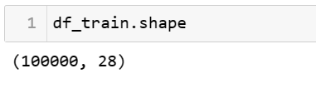

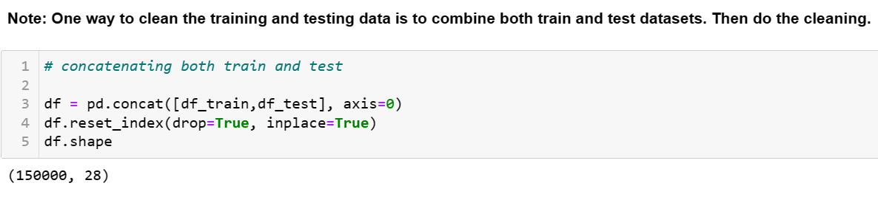

# **DATA EXPLORATION (EDA)**

**Summary of Dataset:**

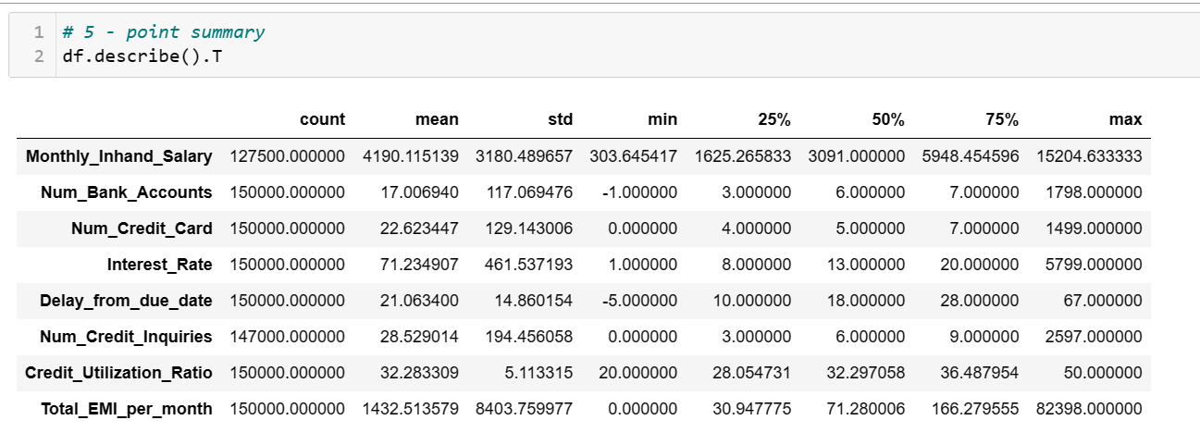

**Interpretation:**

1. Count of all features are not equal so we can say that there are missing values in the Dataset.
2. The difference Between mean and median of each variable is more, so we can say that data is not normally distributed.
3. The difference Between min and max of each variable is more, so we can say that Some of the features also contains potential outliers.

**Check the Data Type:**

**Check the data type of each variable. If the data type is not as per the data definition, change the data type.**

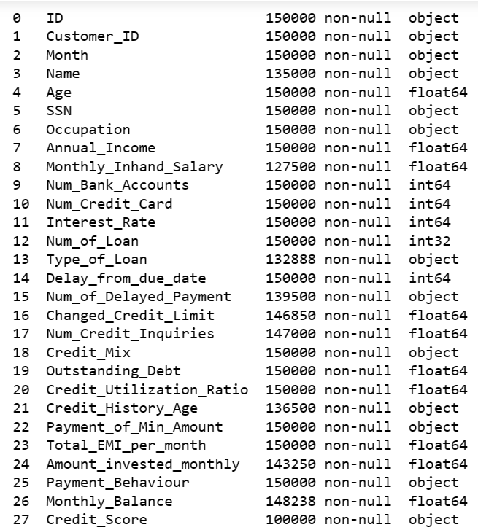

**Data Cleaning :**

Cleaning the Anomalies for all variables and adjust datatype accordingly**:**

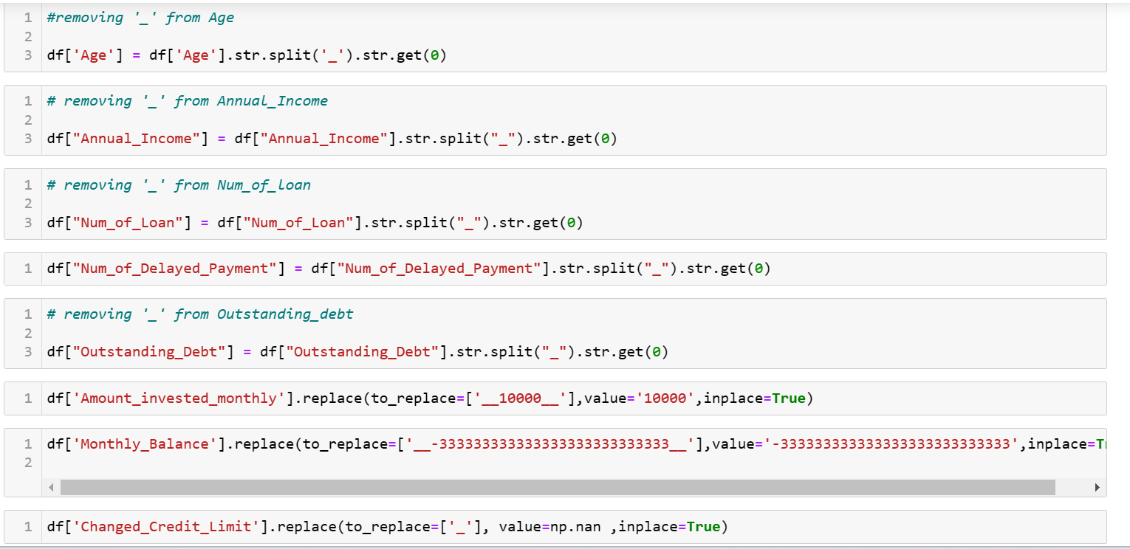

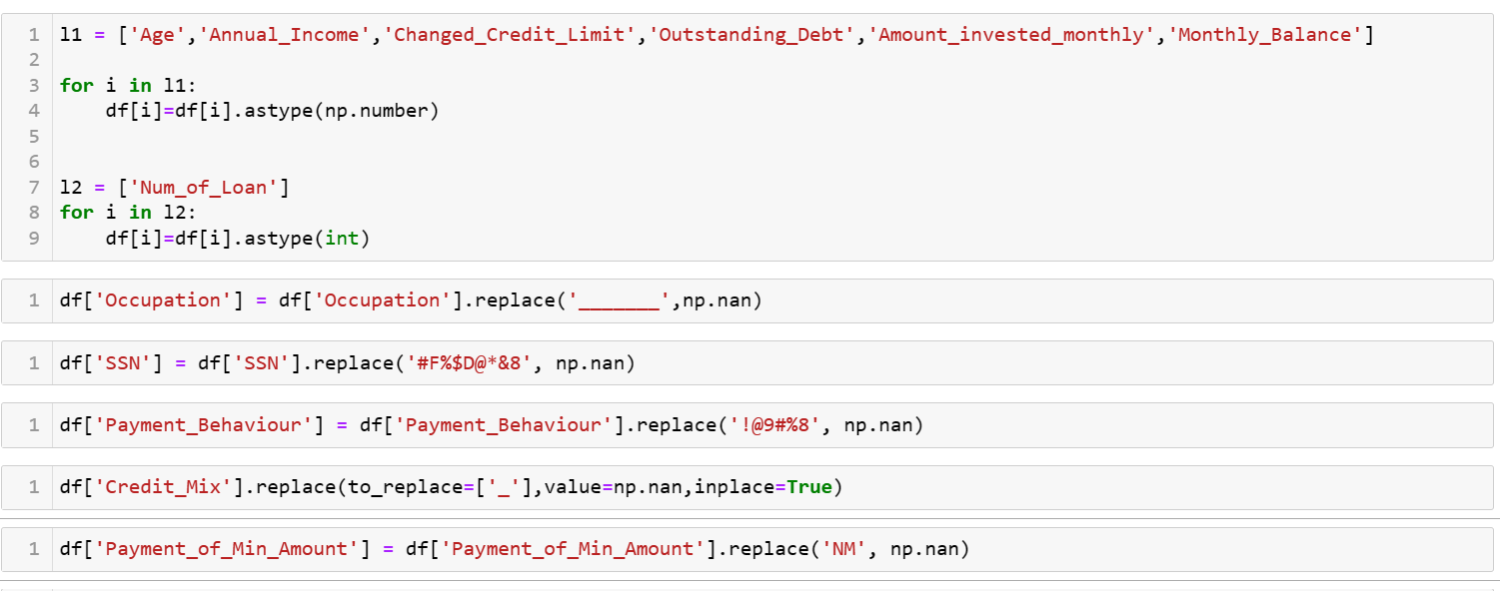

**Missing Values Treatment:**

Missing values plays a prominent role in the dataset. Generally, we can drop the columns or rows depending the percentage of missing values. We can also replace the missing values with optimum values. In order to perform such operations, we will first look into the overall missing values in each column using the below python code.

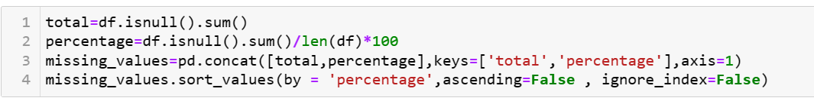

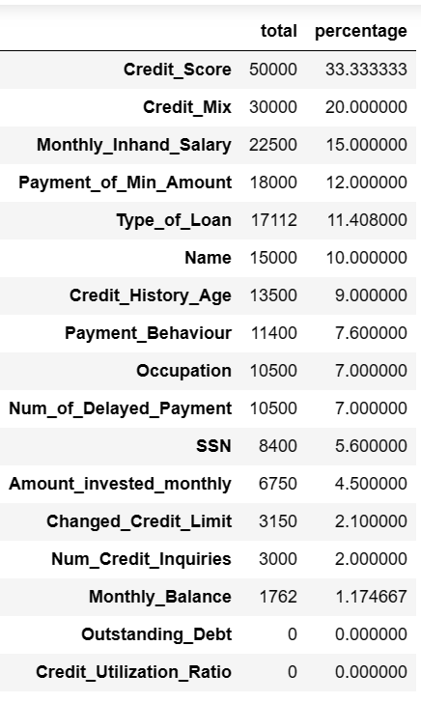

These are the variables with missing values as shown above.

Let us now consider each variable separately for missing value treatment.

### 

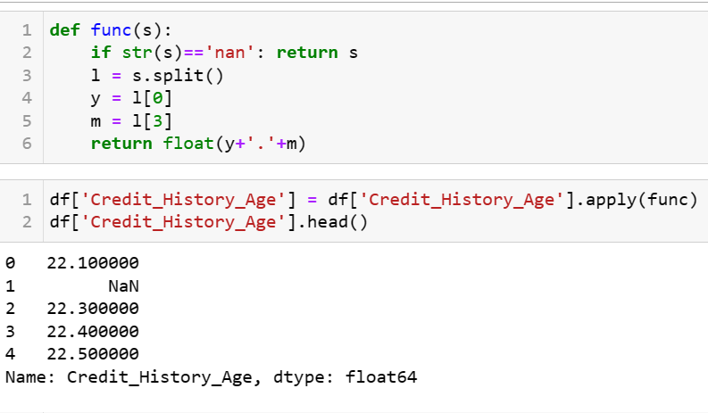

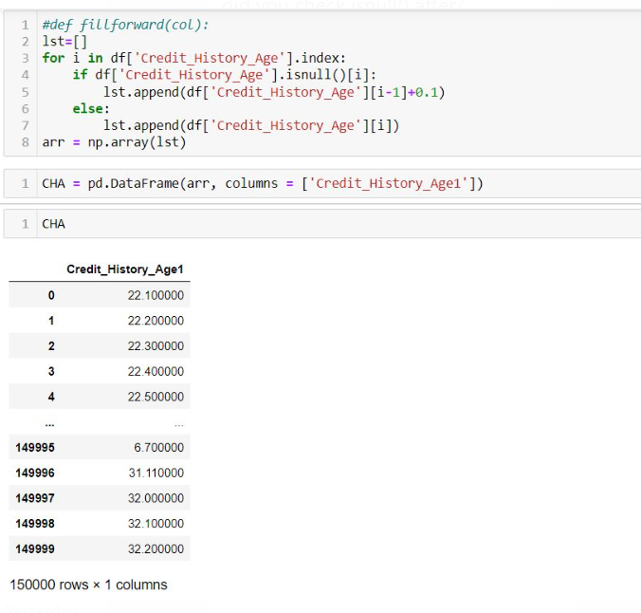

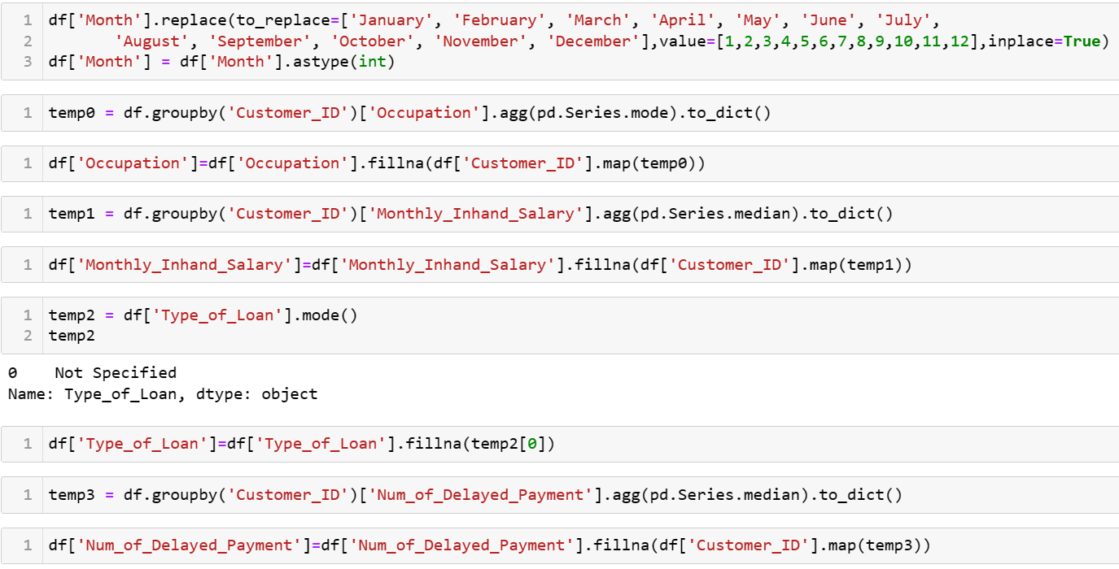

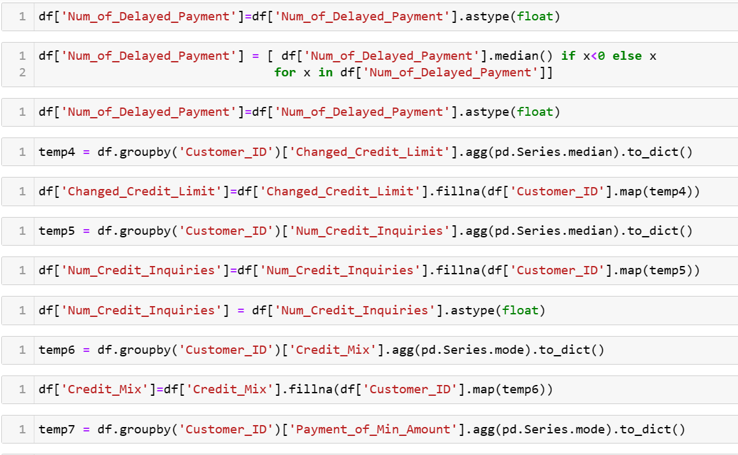

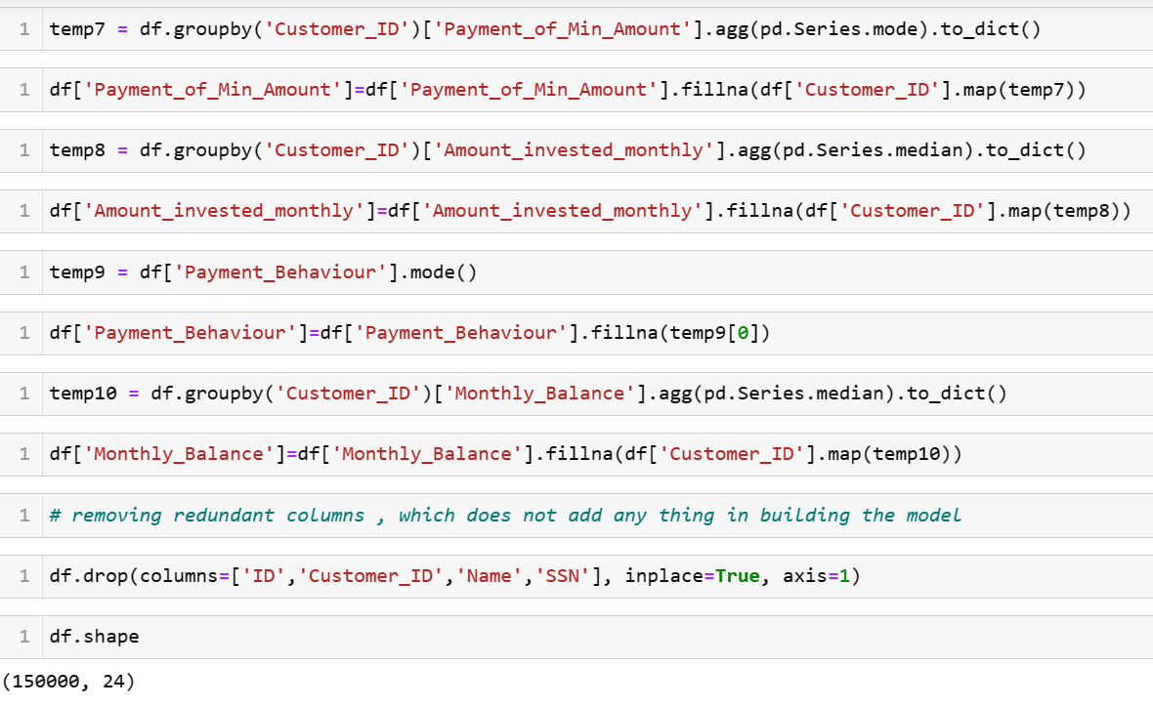

**Final Data Description after cleaning the data and correcting the data types :**

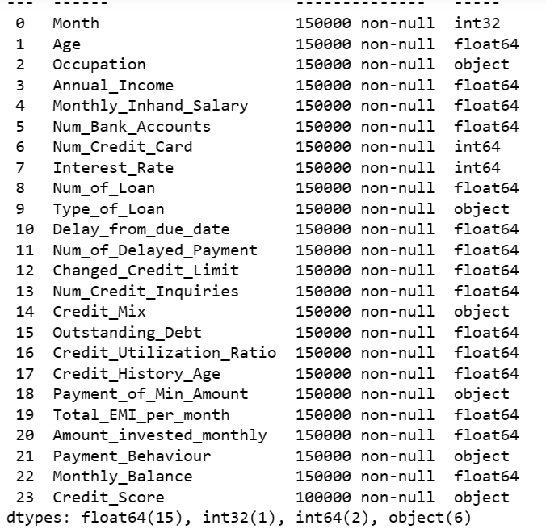

**Inference :**

As from the above description we can find that there are no missing values present in the data and there are 18 numerical data type variables and 6 categorical data type variables.

**Outlier Analysis:**

**Inference:** It is not recommended for outlier treatment for Finance Domain and in the above data set we have customer details , so there might be loss of data on doing outlier treatment.

**Descriptive Analysis (EDA)**

**Univariate Analysis:**

Numerical Columns Visualization:

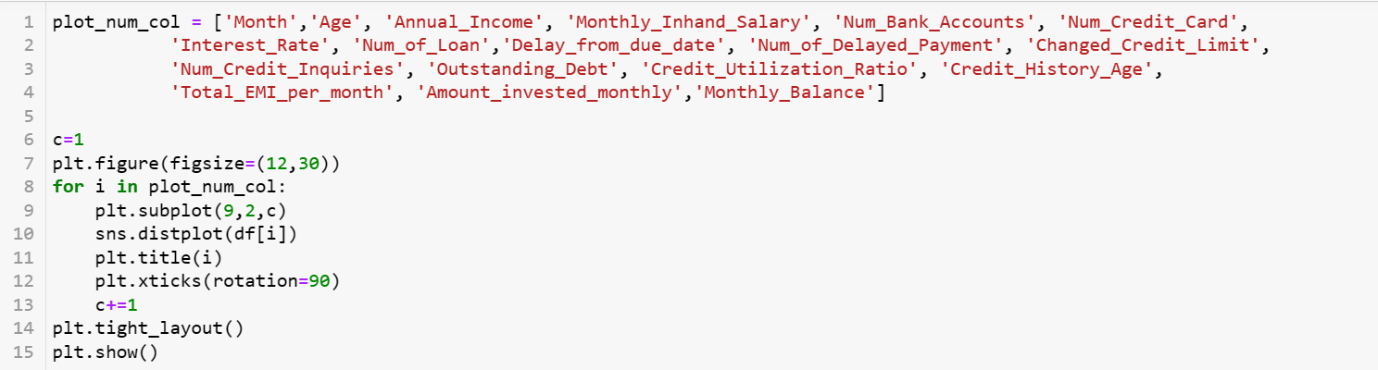

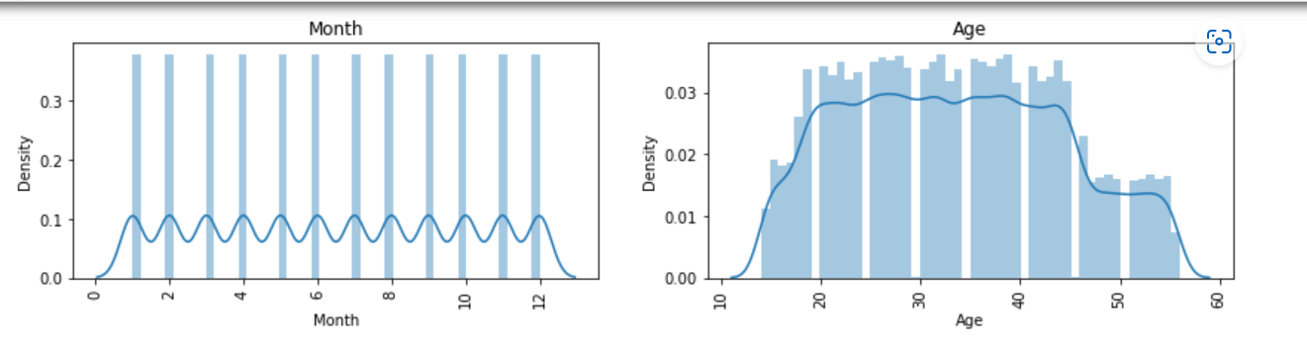

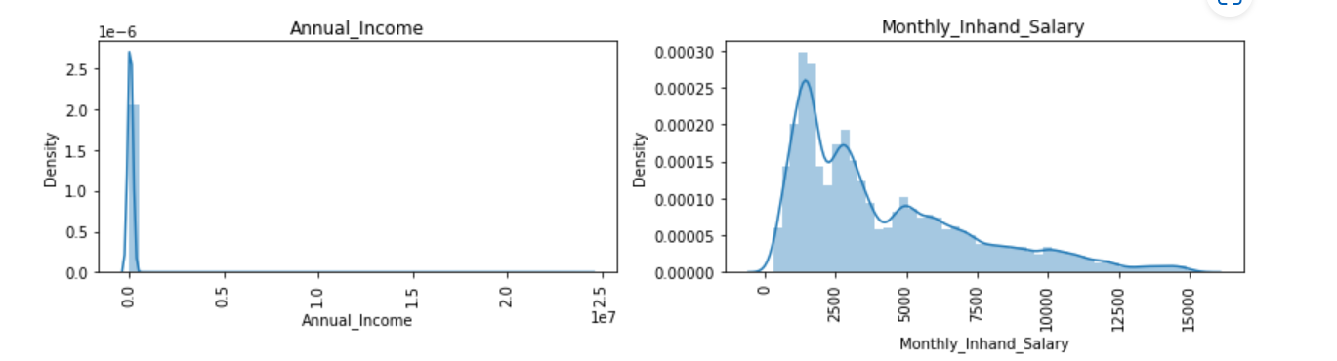

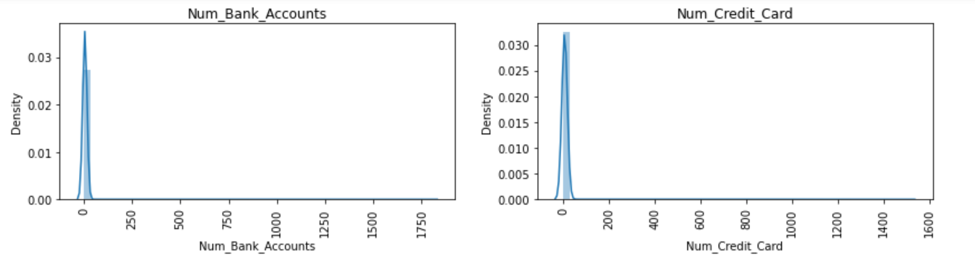

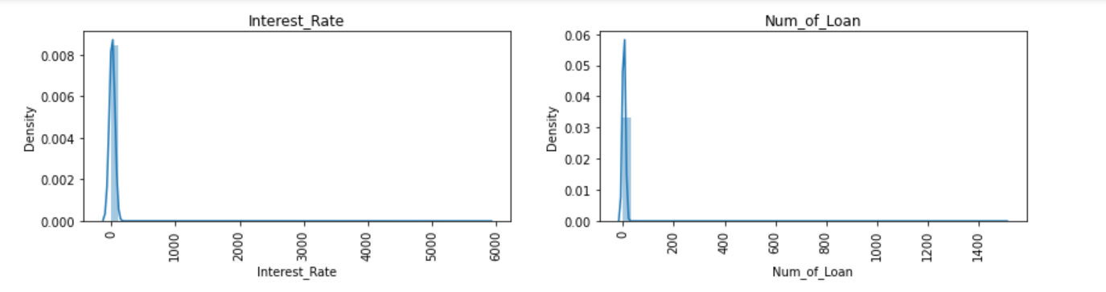

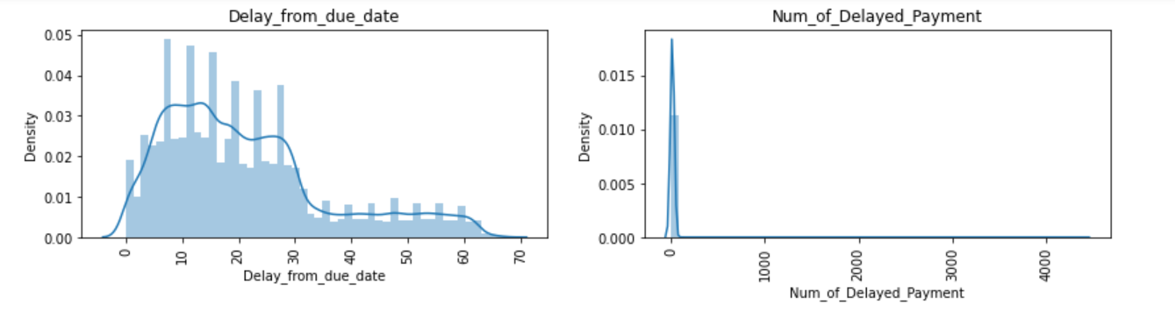

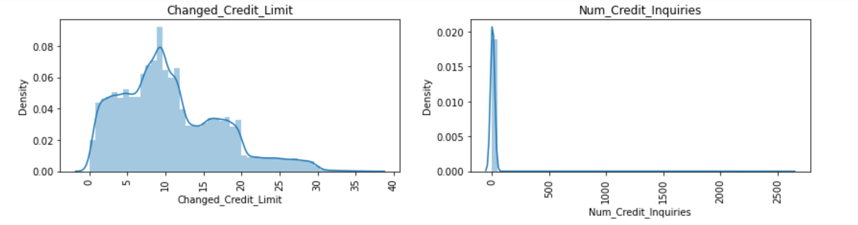

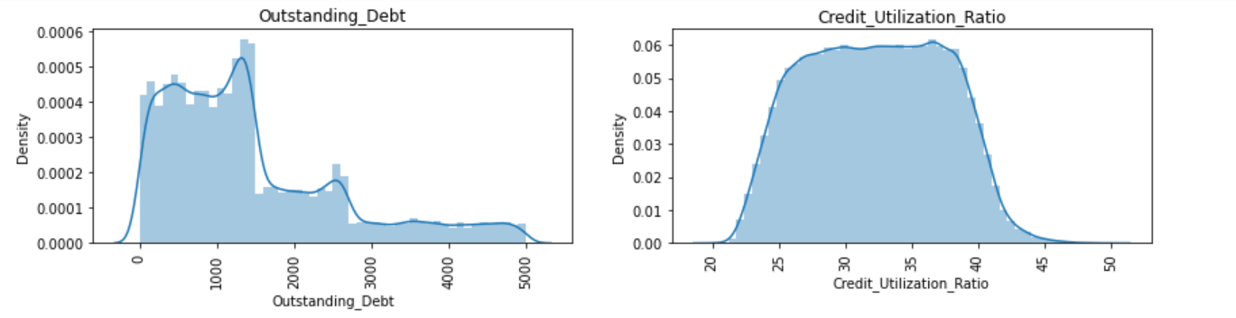

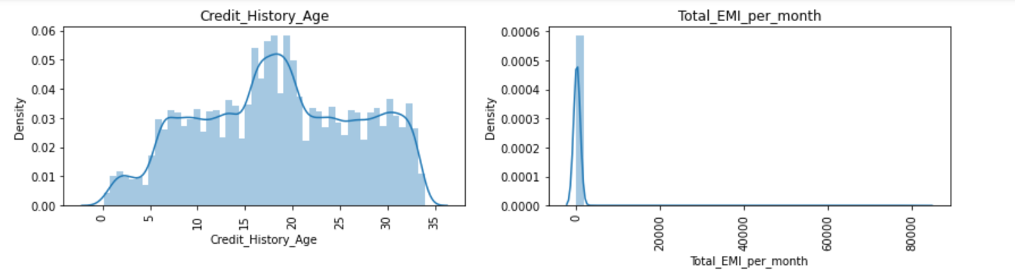

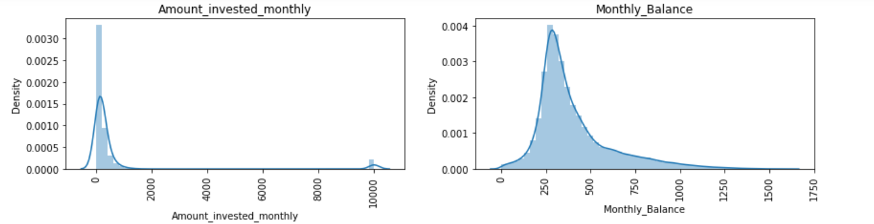

**Observation:** From the above distplots we can observe that ,most of the data is right skewed.

**Categorical Columns Visualization:**

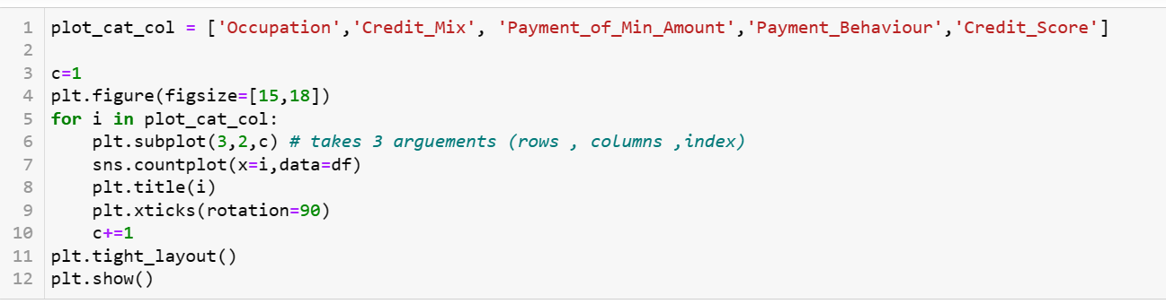

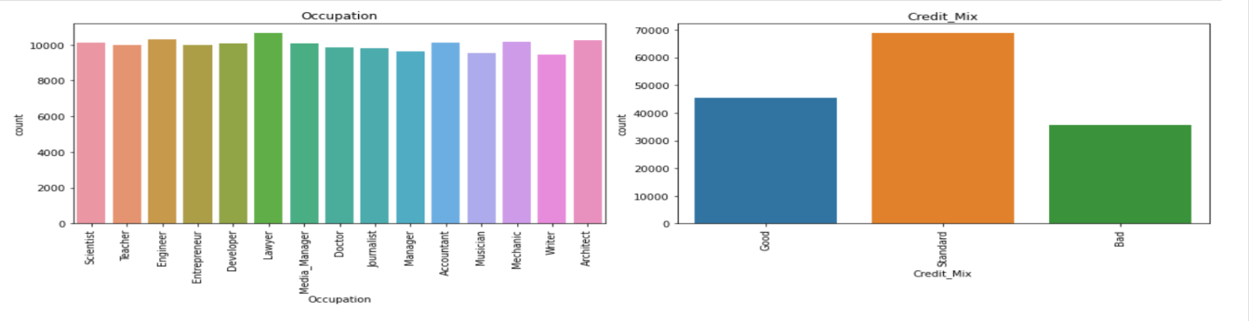

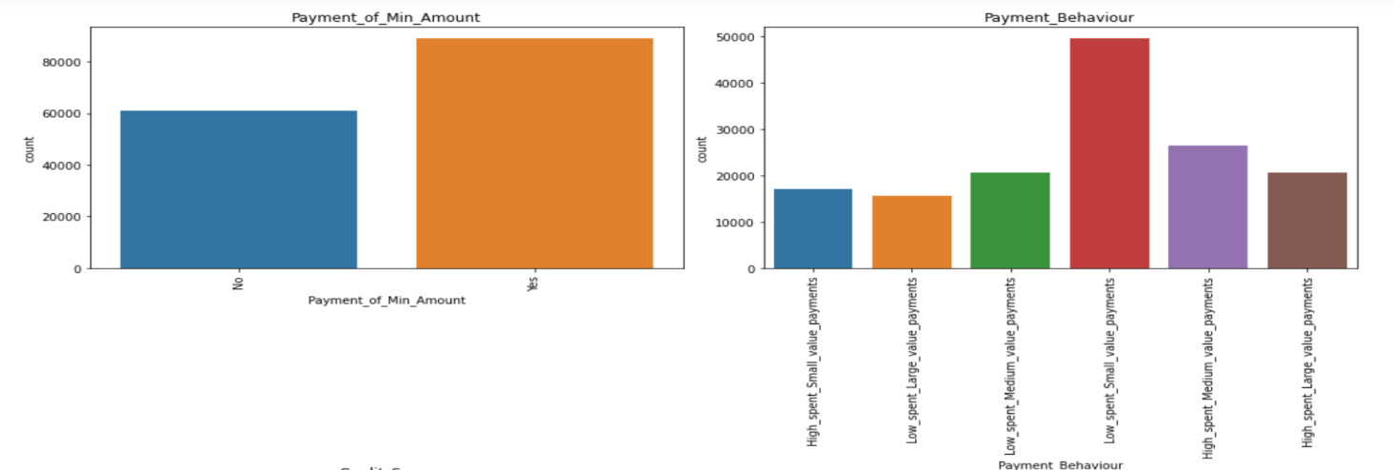

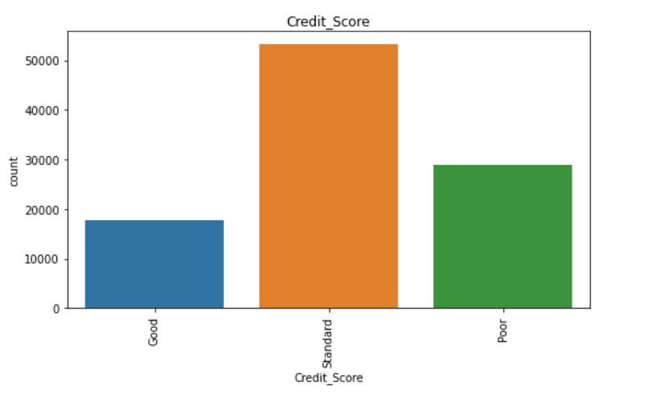

#### Observations:

1) Credit Score has around 50,000 Standard , around 38,000 Poor , around 18,000 Good .

2) All Occupations are around equal range.

3) Credit Mix has Standard , good and followed by bad (count wise)

4) Customers paying minimum amount are more

5) Customers with low spent small value payments are more

**Bivariate Analysis:**

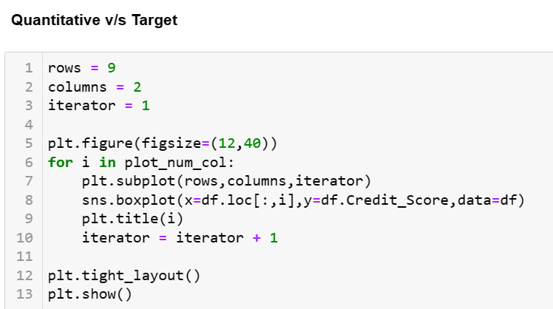

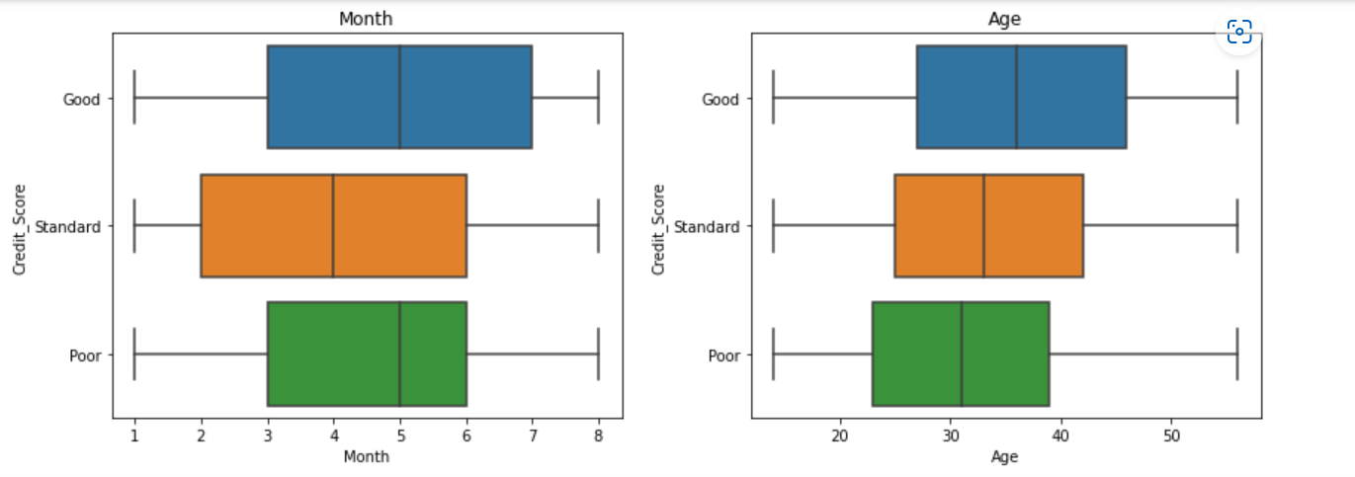

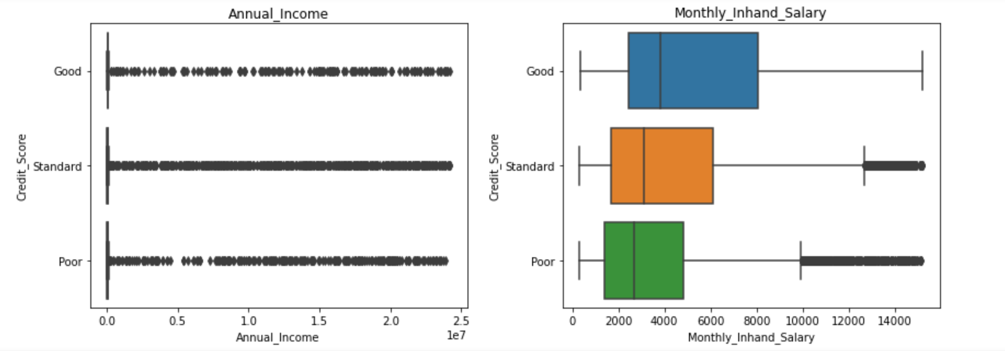

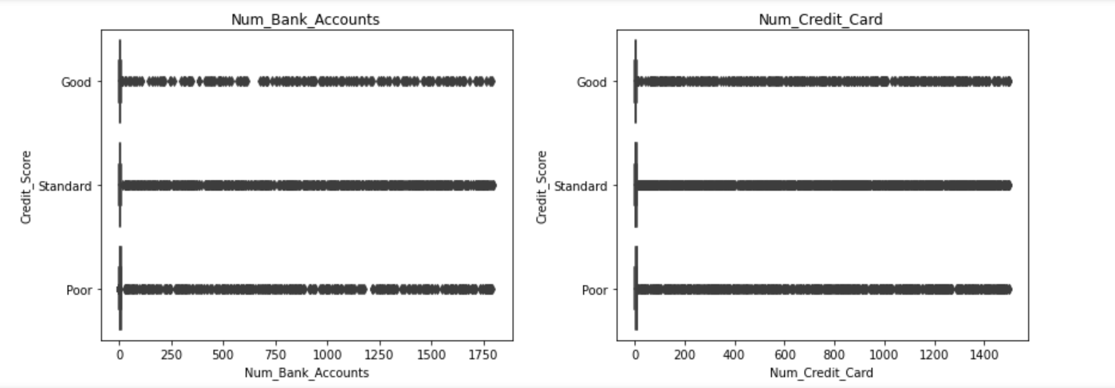

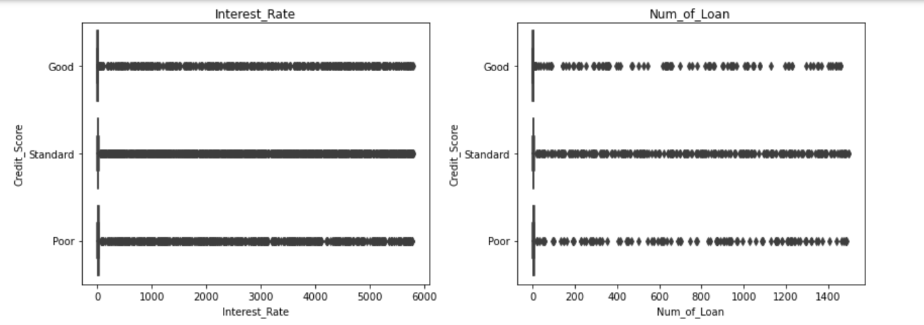

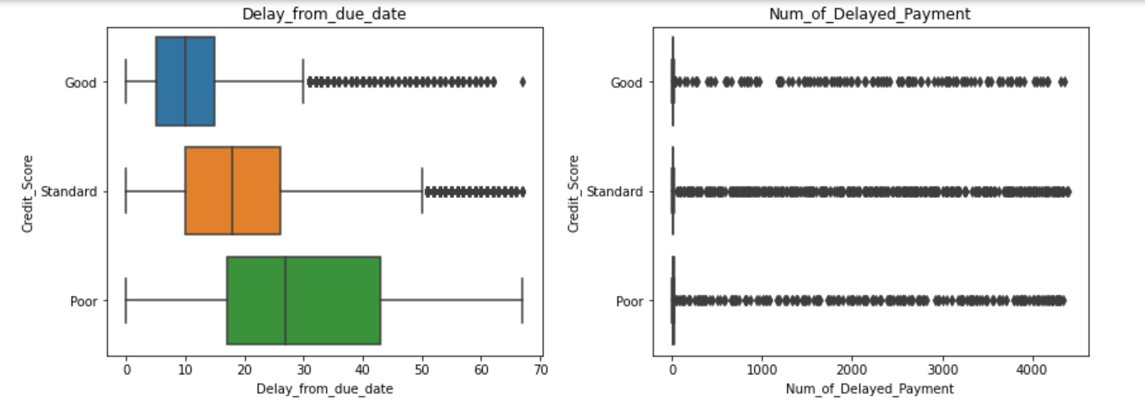

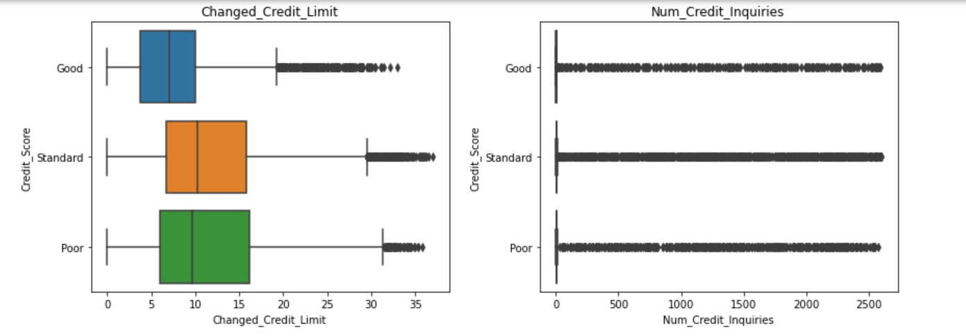

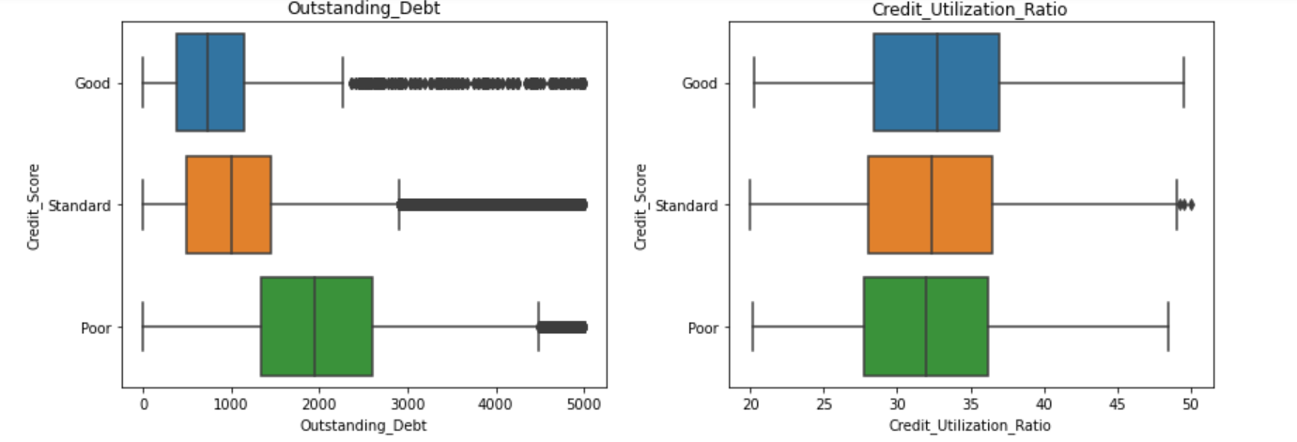

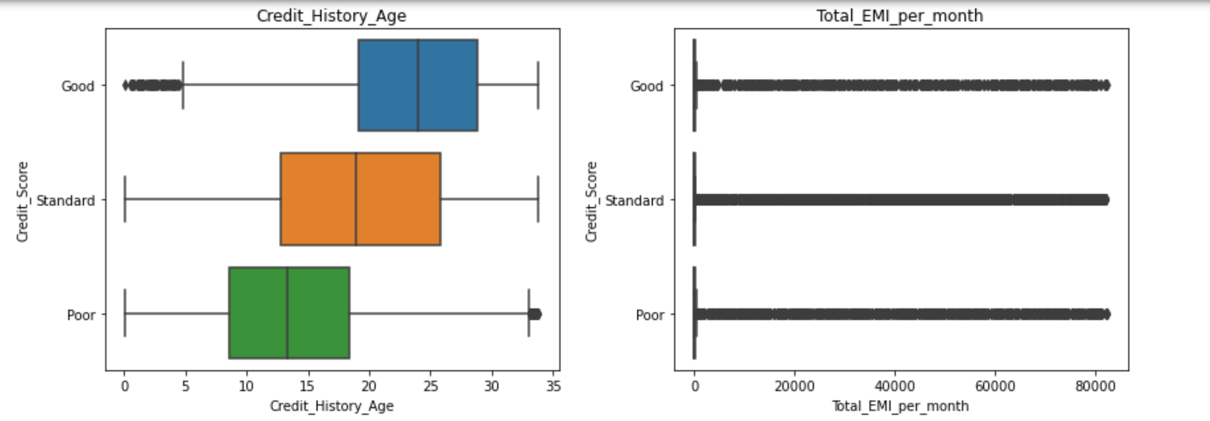

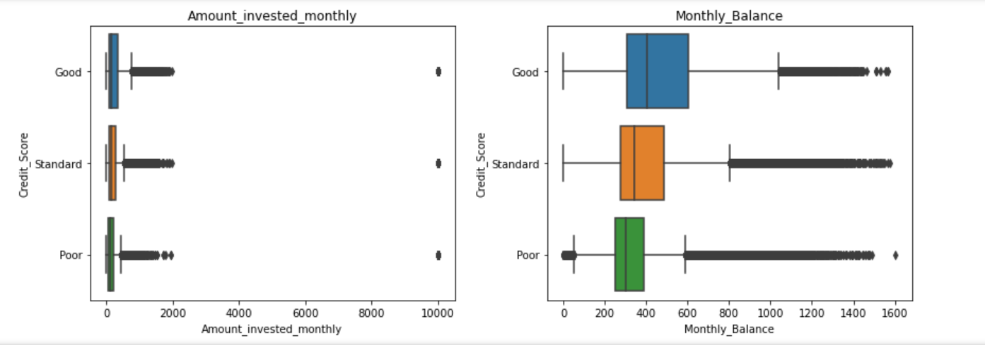

### **Observation:**

1. Good Credit Score lies between the month of 3 and 7 , Poor lies between the month of 3 to 6 , Standard lies between the month of 2 and 6 .
2. Customers having Good Credit Score has more monthly inhand salary.
3. Customers having Poor Credit Score are of age between 23 to 37
4. Customers having Poor Credit Score has more delayed from due date payments and Outstanding debt , .
5. Credit history Age of Customers with Good Credit Score are of range 18 to 28.
6. Monthly Balance is more for Customers with Good Credit Score

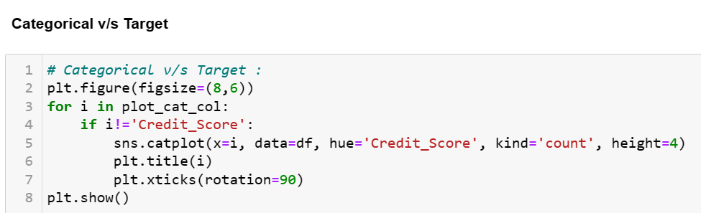

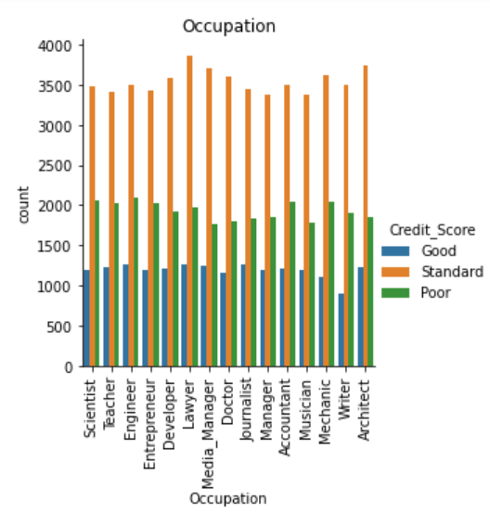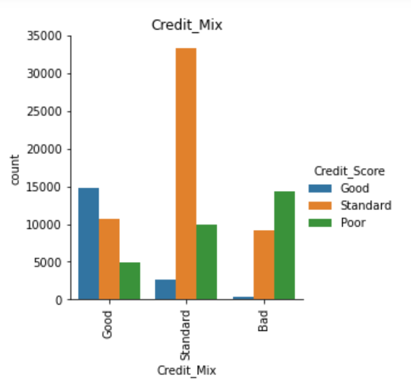

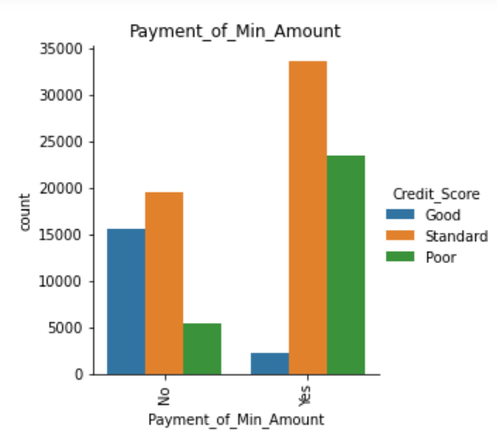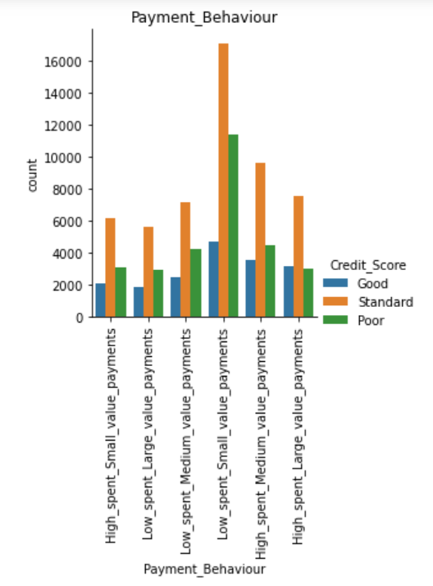

**Multivariate Analysis:**

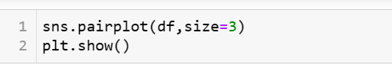

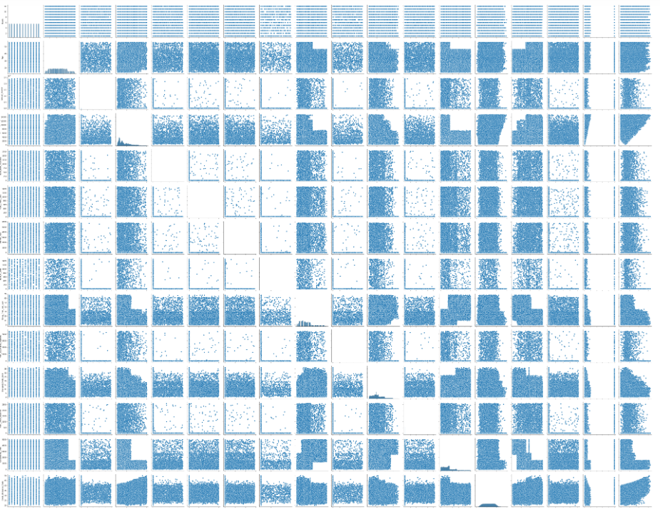

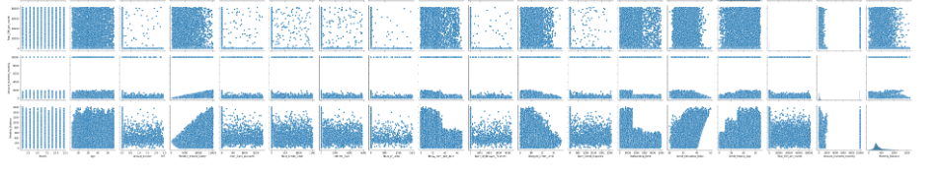

**Observation:**

According to plot, there is no patterns visible, it could indicate that there is no significant correlation or relationship between the variables being plotted.

A pair plot is a type of data visualization that displays scatter plots of multiple pairs of variables in a matrix format, with histograms or kernel density plots on the diagonal. It is commonly used to explore relationships and patterns between variables in a dataset.

If no patterns are visible in a pair plot, it could mean that the variables being plotted do not exhibit any discernible patterns of correlation or association.

**Statistics (Stats)**

**Statistcal test**

* **Num v/s Target**

Kruskal-Wallis test, which is a nonparametric statistical test used to compare the median ranks of three or more independent groups. It is often used as an alternative to the parametric one-way analysis of variance (ANOVA) test when the assumptions of normality and equal variance are not met

If p values less than 0.05, we can say categorical groups are different.

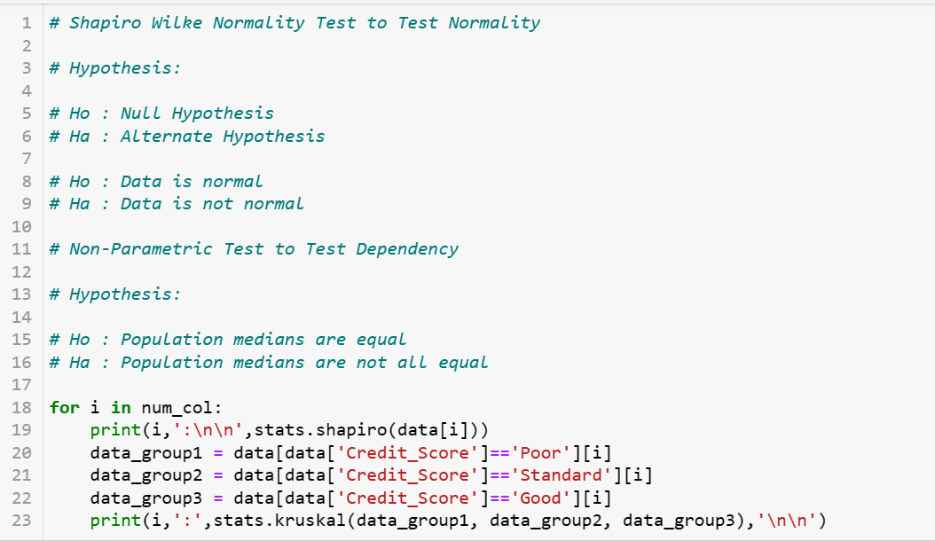

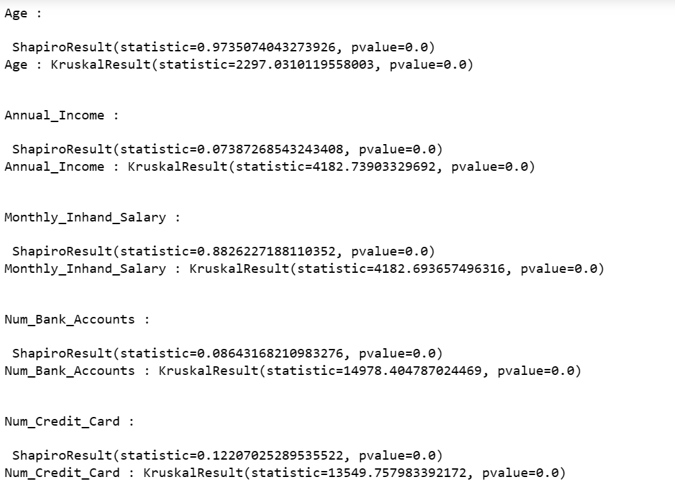

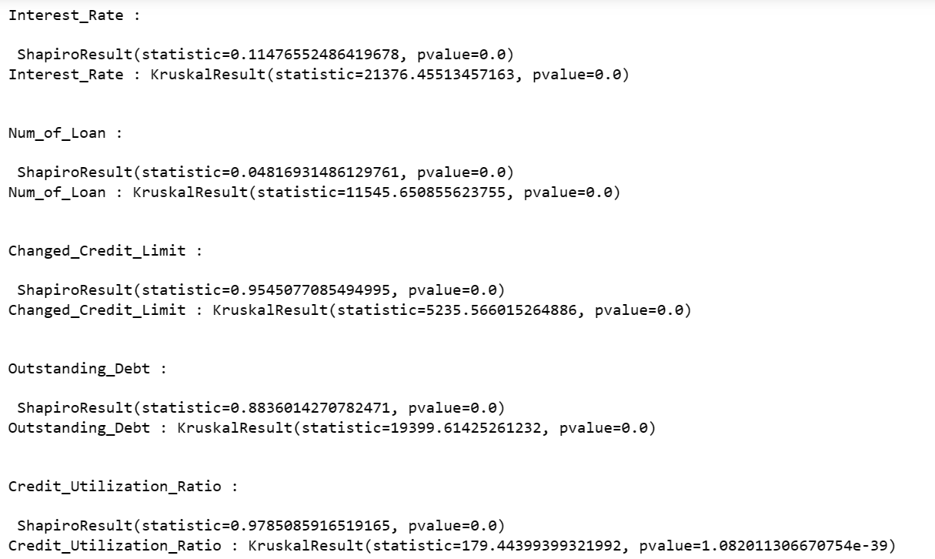

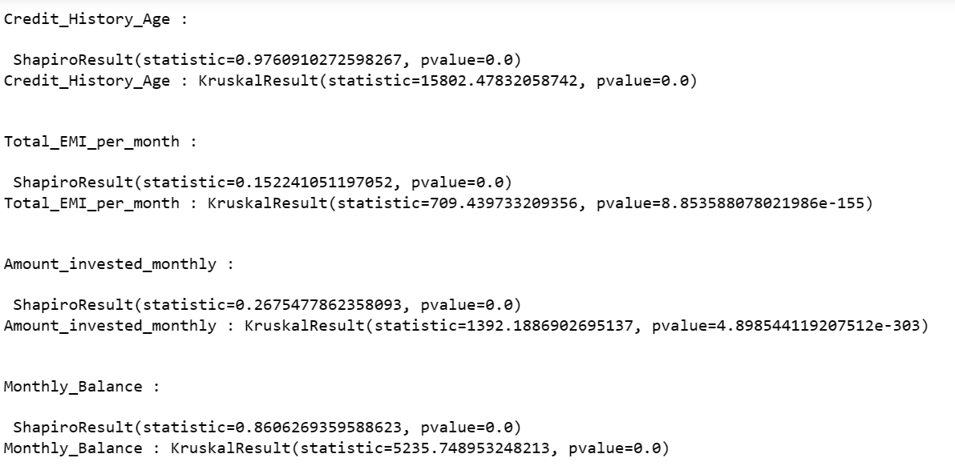

**Inference :**

**Since from the above results we conclude that p_value is less than the significance level so, we reject null hypothesis and concluding that Data is not Normal and Credit Score for each category is dependent to each other for given independent variables.**

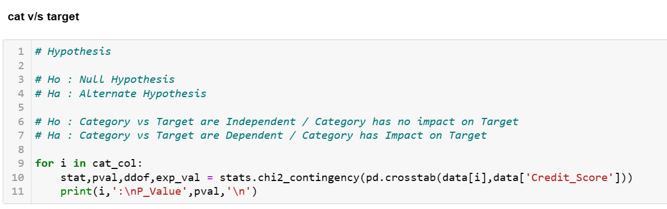

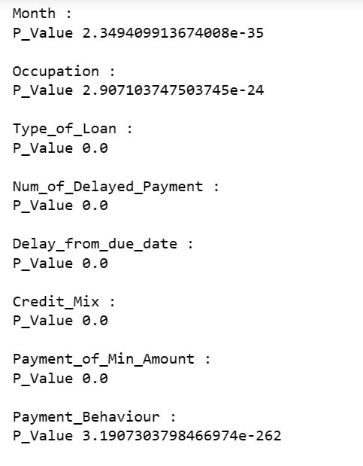

**Inference :**

**Since from the above results we conclude that p_value is less than the significance level so, we reject null hypothesis and concluding that Credit Score for each category is dependent.**

**Interpretation(statistical tests):**

Based on the p-values obtained from the Shapiro-Wilk normality test and Kruskal-Wallis test, it appears that all the features have significantly low p-values (p < 0.05), indicating that the distributions of the features are significantly different across the different categories of the target variable (credit score). This suggests that these features may be important predictors of the credit score.

**Class Imbalance and its Treatment:**

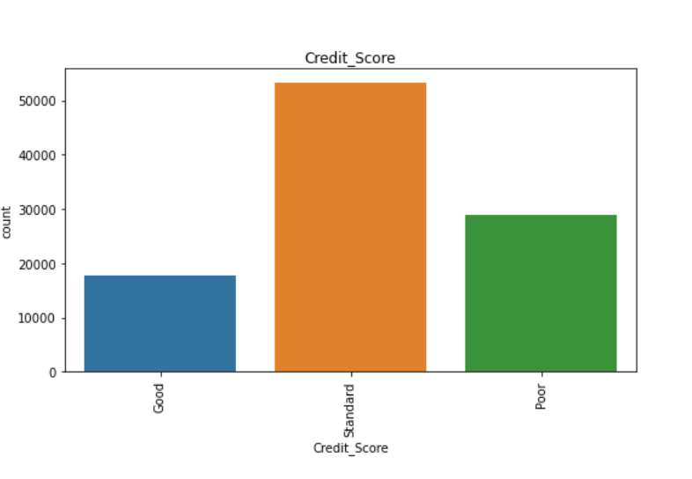

Here we can see that our target variable is too imbalanced, and to treat that we not going to use oversampling techniques like smote , because for real time data Smote is not recommended as we manually input the data.

**Encoding :**

In the context of data analysis, encoding refers to the process of converting categorical or qualitative variables into numerical or quantitative values that can be used for analysis. This is necessary because many statistical and machine learning algorithms require numerical input for processing and analysis.

Here encoding is done individualy depending upto that variable :

Encoding Categorical Variables :

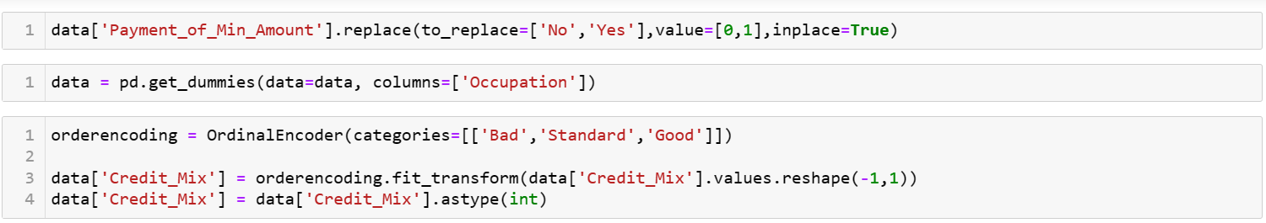



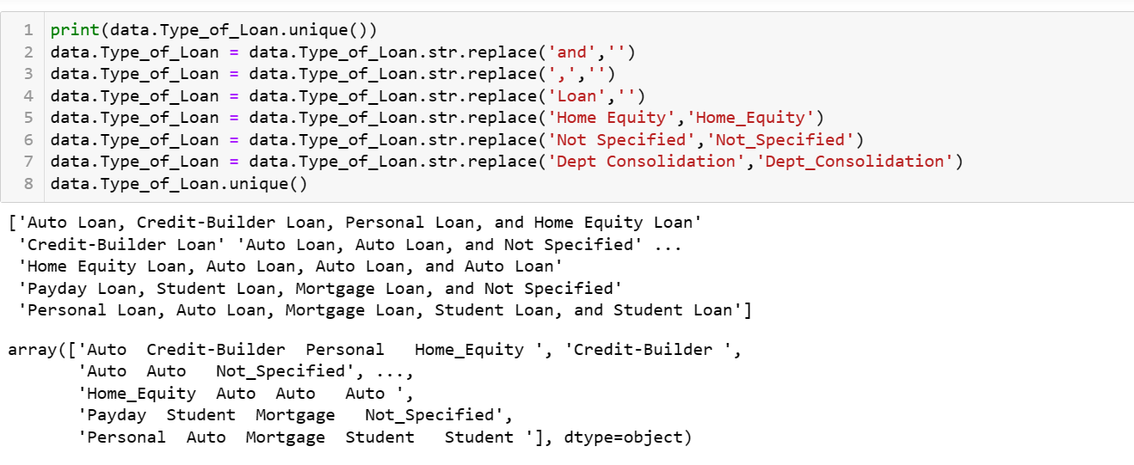

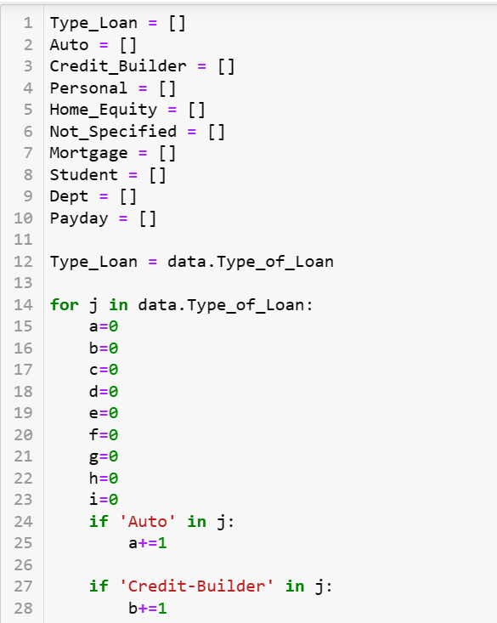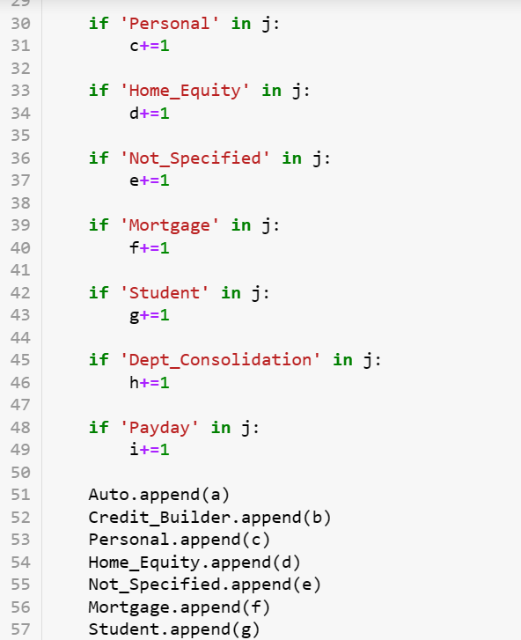

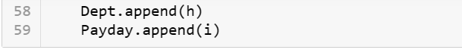

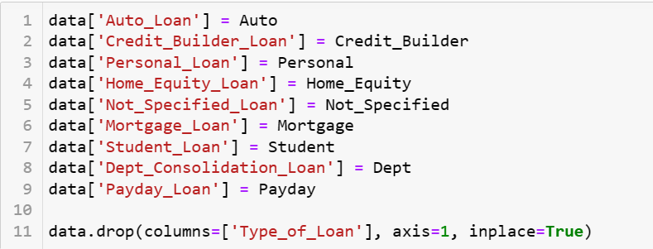

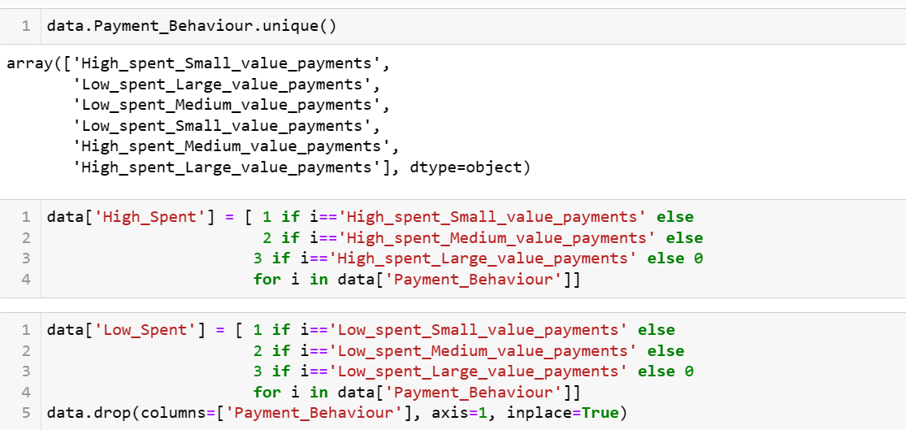

**Transformation:**

Transformation is a process that can be used to change the scale of the original data to get more accurate results.We use log1p transformation.

The log1p transformation is a data transformation technique used in data science and machine learning that involves applying the natural logarithm (base e) to the values of a dataset after adding 1 to each value. It is often used for data that contains skewed or heavily right-skewed distributions, where the values are concentrated towards lower values and have a long tail towards higher values.

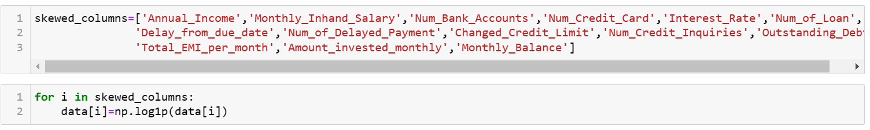

**Scaling :**

Scaling is often applied to numerical features or variables to ensure that they are on a comparable scale and to avoid biases in the analysis due to differences in units or scales.

We are using Standard scaler and Robust Scaler both based on skewness :

The StandardScaler is a popular scaling technique used in data science and machine learning that performs z-score normalization, also known as standardization. It is a preprocessing step that transforms the values of a variable to have zero mean and unit variance, making them on a comparable scale.

The RobustScaler is a data scaling technique used in data science and machine learning that is robust to outliers. It is a preprocessing step that scales the values of a variable by removing the median and scaling by the interquartile range (IQR), which is the difference between the 75th and 25th percentiles. This makes it less sensitive to the presence of outliers compared to standardization or normalization techniques like z-score normalization or min-max scaling.

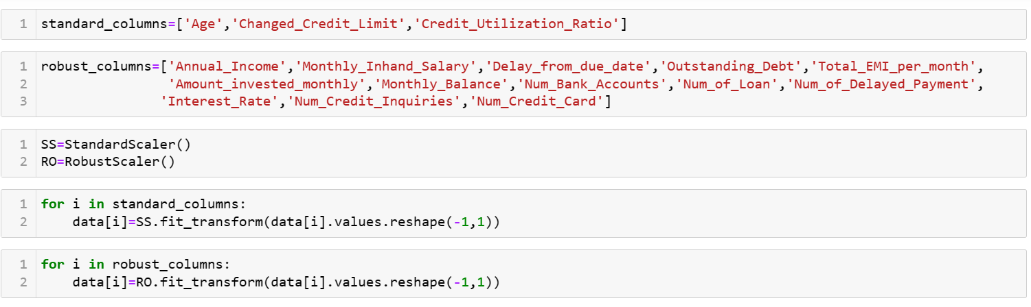

**Feature Engineering :**

Feature engineering is a crucial step in the data science and machine learning pipeline where raw data is transformed into meaningful and informative features that can be used as input to train a machine learning model.

Feature Selection :

This involves selecting a subset of relevant features from the available dataset. It can be done using techniques such as correlation analysis, mutual information, or using domain knowledge to identify features that are likely to have a strong relationship with the target variable.

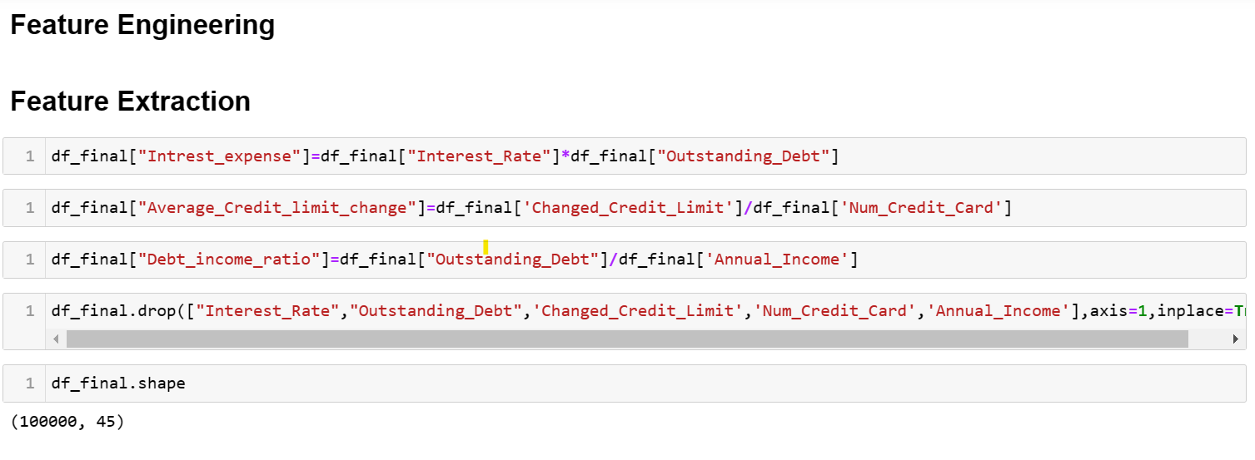

**Train Test Split :**

Train-test split is a common technique used in machine learning and data science to evaluate the performance of a model on unseen data. It involves dividing a dataset into two separate parts: a training set and a testing (or validation) set. The training set is used to train the model, while the testing set is used to evaluate the model's performance and estimate its generalization performance on unseen data.

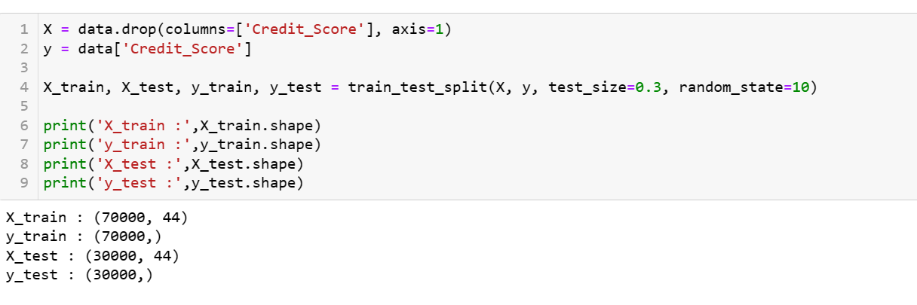

**Variance Inflation Factor (VIF)**

VIF is a statistical measure used to assess the multicollinearity or the presence of linear dependencies among predictor variables in a regression model. VIF measures the extent to which the variance of an estimated regression coefficient is inflated due to the presence of correlated predictors in the model. It is commonly used in feature selection or model building to identify and address multicollinearity issues, which can affect the interpretability and stability of regression models**.**

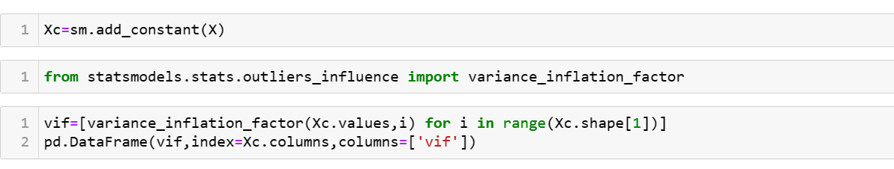

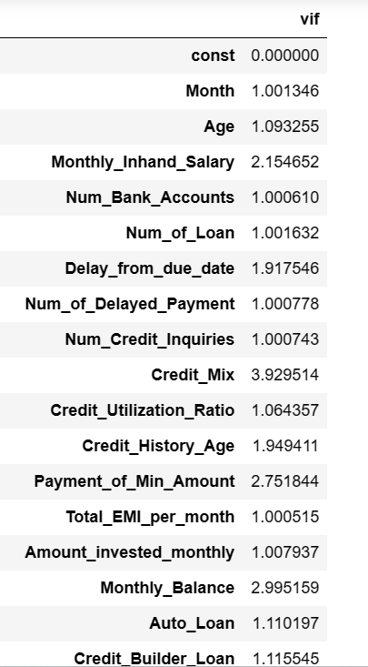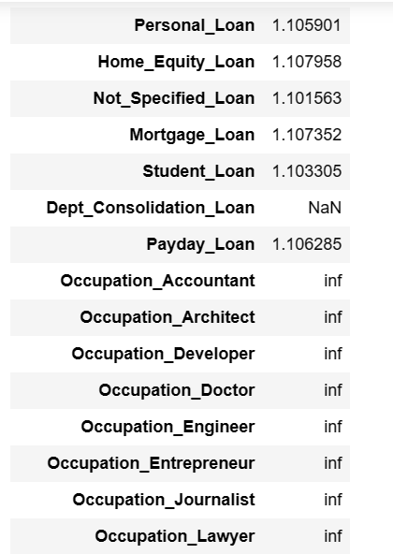 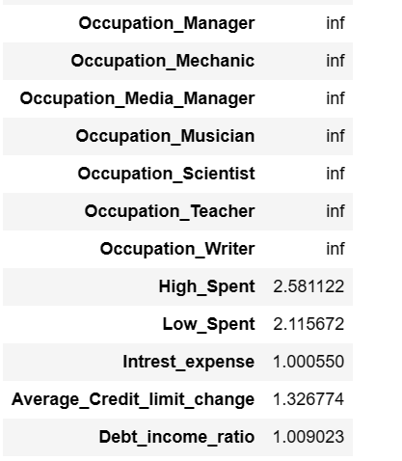

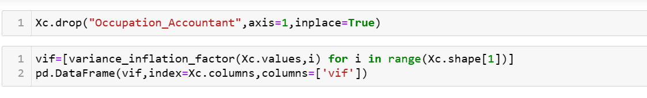

**Inference :**

After dropping the VIF of all the features are less then 9 , hence we are considering all the features except Occupation_Accontant.

**Model Building**

Creating a user defined function for :

Classification report, Confusion matrix, ROC-AUC curve

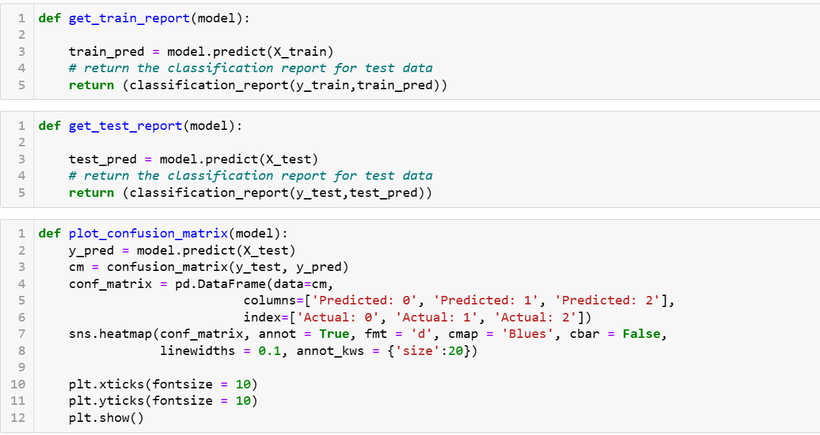

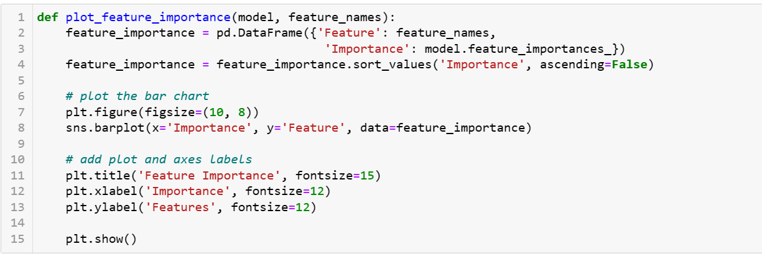

## 

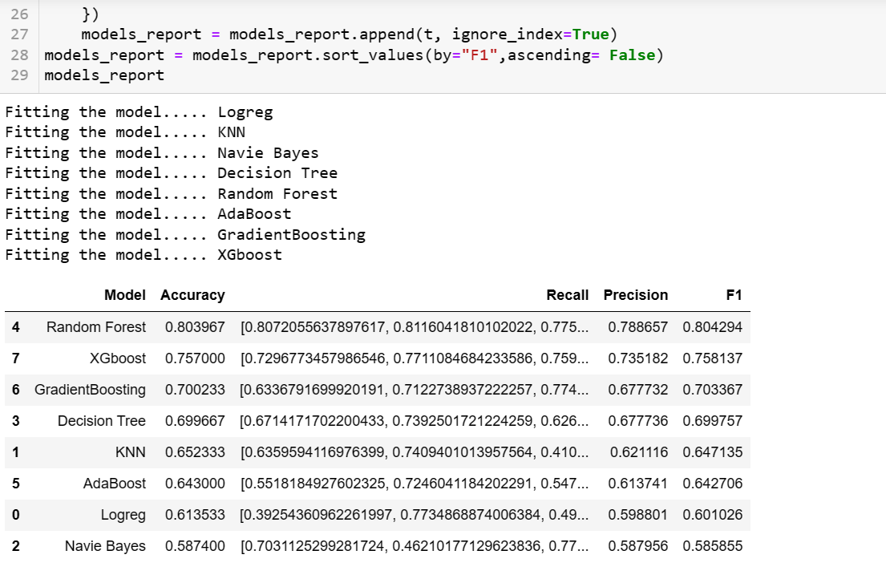

## **Benchmark model (Base Model) : Naive Bayes Algorithm**

## It uses a Bayes' Theorem with the assumption of independence of predictor variables. The sklearn library provides different naive bayes classifiers, as GaussianNB, MultinomialNB and so on.

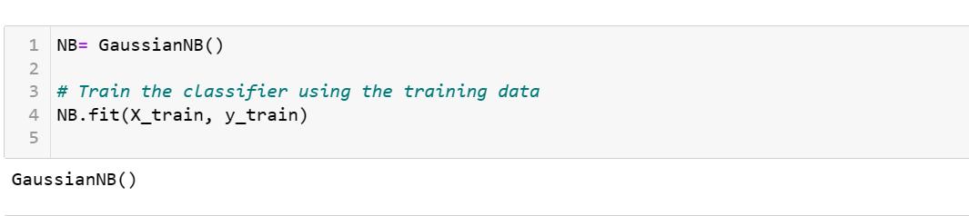

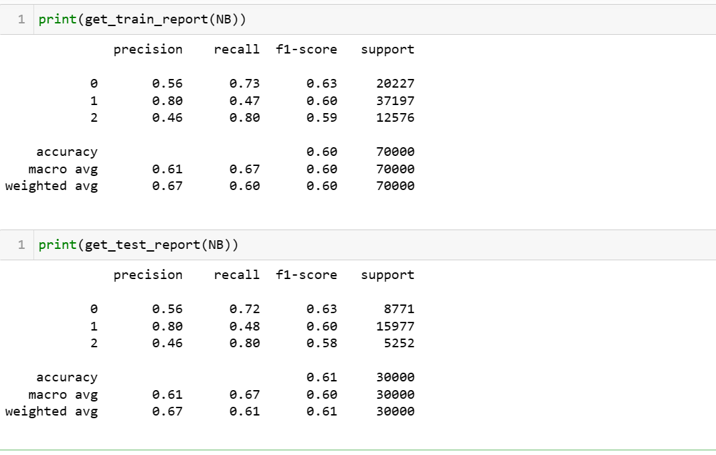

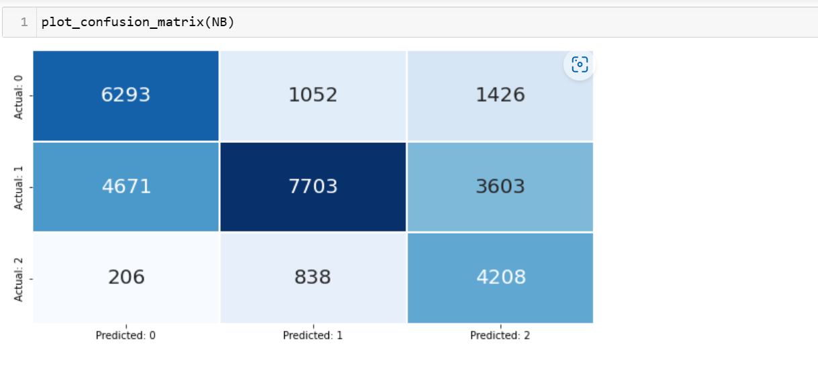

**Interpretation:**

Precision:

Precision for class 0 is 0.56, which means that out of all instances predicted as class 0, 56% (precision=0.56) are actually of class 0.

Precision for class 1 is 0.80, which means that out of all instances predicted as class 1, 80% (precision=0.80) are actually of class 1.

Precision for class 2 is 0.46, which means that out of all instances predicted as class 2, 46% (precision=0.46) are actually of class 2.

Recall:

Recall for class 0 is 0.72, which means that out of all instances of class 0, 72% (recall=0.72) are correctly identified as class 0.

Recall for class 1 is 0.48, which means that out of all instances of class 1, 48% (recall=0.48) are correctly identified as class 1.

Recall for class 2 is 0.80, which means that out of all instances of class 2, 80% (recall=0.80) are correctly identified as class 2.

Overall Accuracy is 0.61 and F1- Score is 0.63

**Decision Tree**

Decision Tree is a non-parametric supervised learning method. It builds a model in the form of a tree structure. It breaks down a dataset into smaller and smaller subsets, which is called splitting. A decision node is a node on which a decision of split is to be made. A node that can not be split further is known as the terminal/leaf node. A leaf node represents the decision. A decision tree can work with both numerical and categorical variables.

A decision tree for classification is built using criteria like the Gini index and entropy.

## Gini Index

Gini index measures the probability of the sample being wrongly classified. The value of the Gini index varies between 0 and 1. We choose the variable with a low Gini index

## Entropy

Entropy is one of the criteria used to build the decision tree. It calculates the heterogeneity of the sample. The entropy is zero if the sample is completely homogeneous, and it is equal to 1 if the sample is equally divided.

The information gain is the difference between the entropy of the target variable and the entropy of the target variable given an independent variable. We split the on the variable that corresponds to the highest information gain.

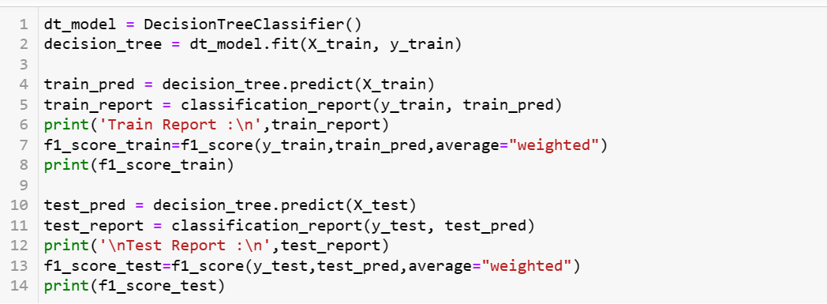

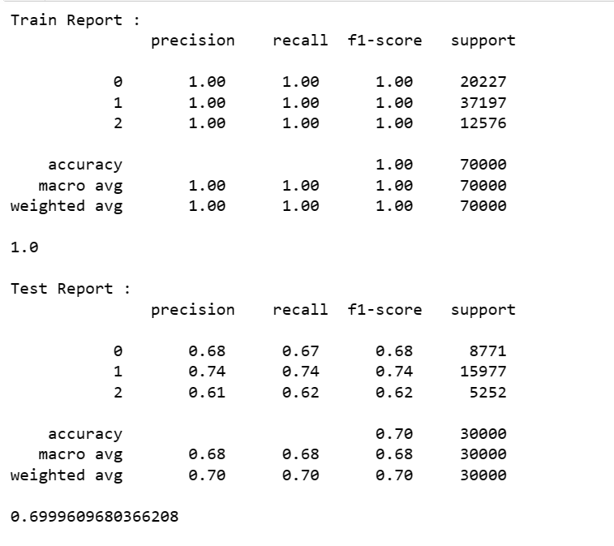

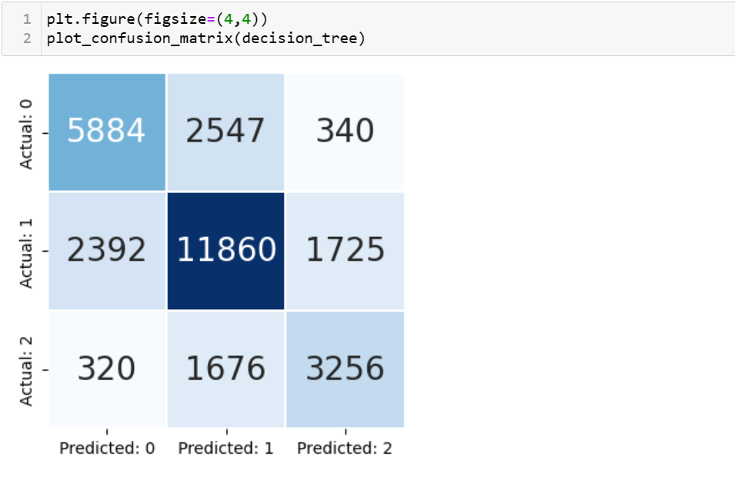

**Interpretation:**

Precision:

Precision for class 0 is 0.69, which means that out of all instances predicted as class 0, 69% are actually of class 0.

Precision for class 1 is 0.74, which means that out of all instances predicted as class 1, 74% are actually of class 1.

Precision for class 2 is 0.61, which means that out of all instances predicted as class 2, 61% are actually of class 2.

Recall:

Recall for class 0 is 0.67, which means that out of all instances of class 0, 67% are correctly identified as class 0.

Recall for class 1 is 0.74, which means that out of all instances of class 1, 74% are correctly identified as class 1.

Recall for class 2 is 0.62, which means that out of all instances of class 2, 62% are correctly identified as class 2.

The model has good recall for class 2, but poor recall for class 1. Additionally, the model has relatively low precision for all three classes. F1 score is 0.69. Overall accuracy of the model is 0.70.

**Decision Tree Feature Importance**

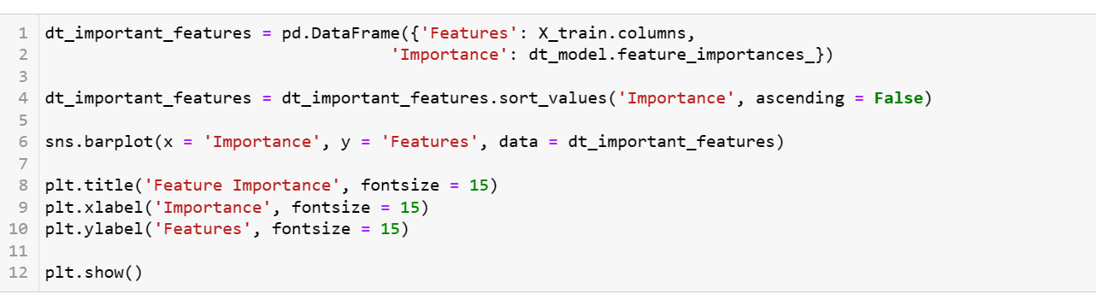

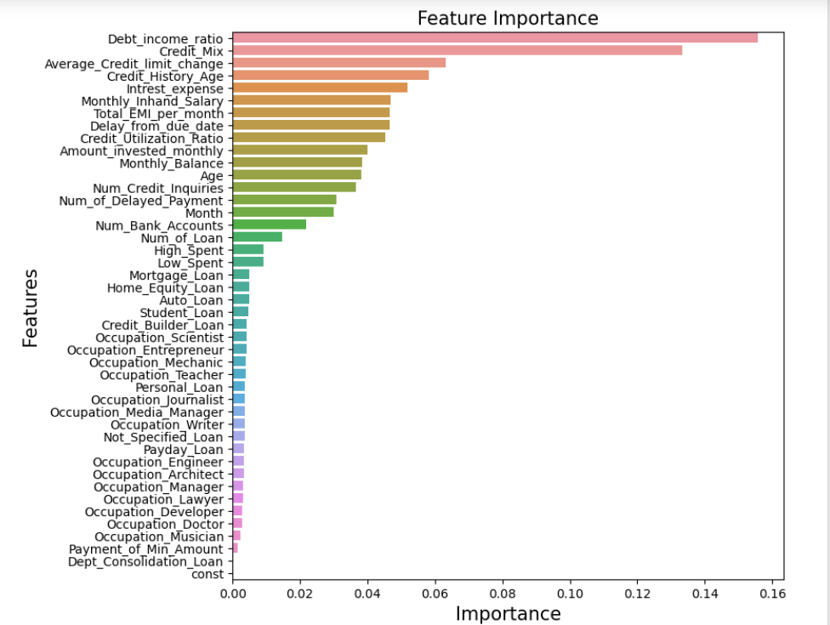

**Tuned Decision Tree using Grid Search CV**

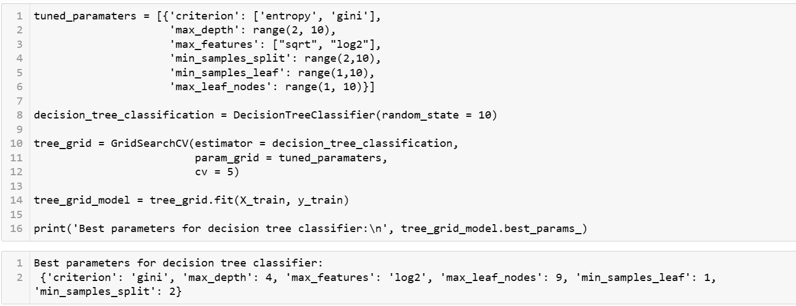

**Decision Tree with Best Parameters**

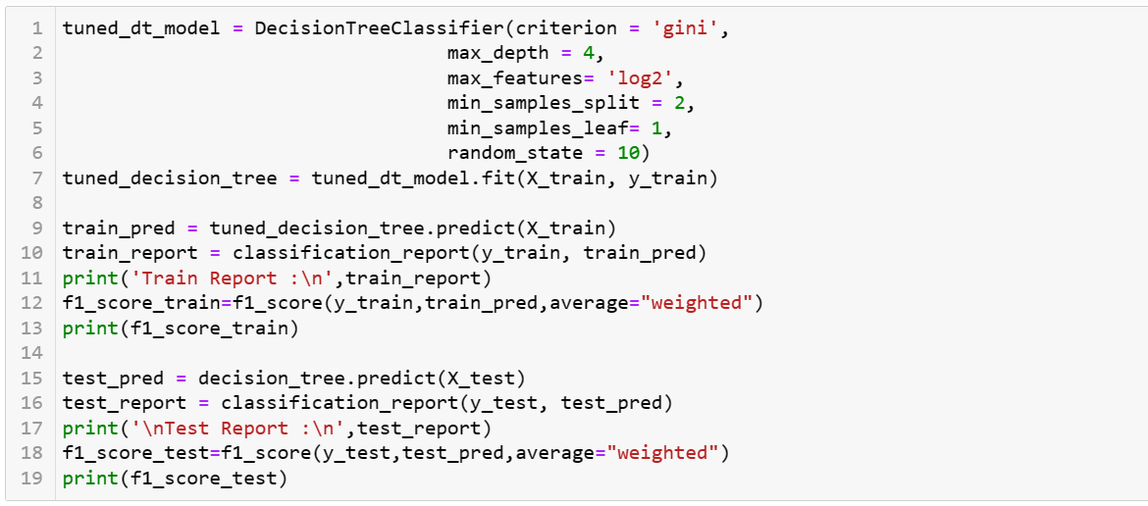

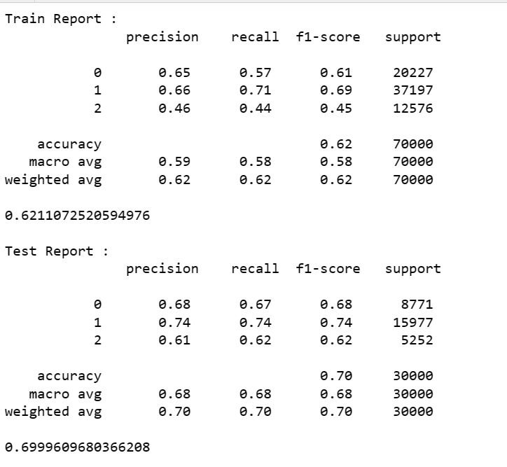



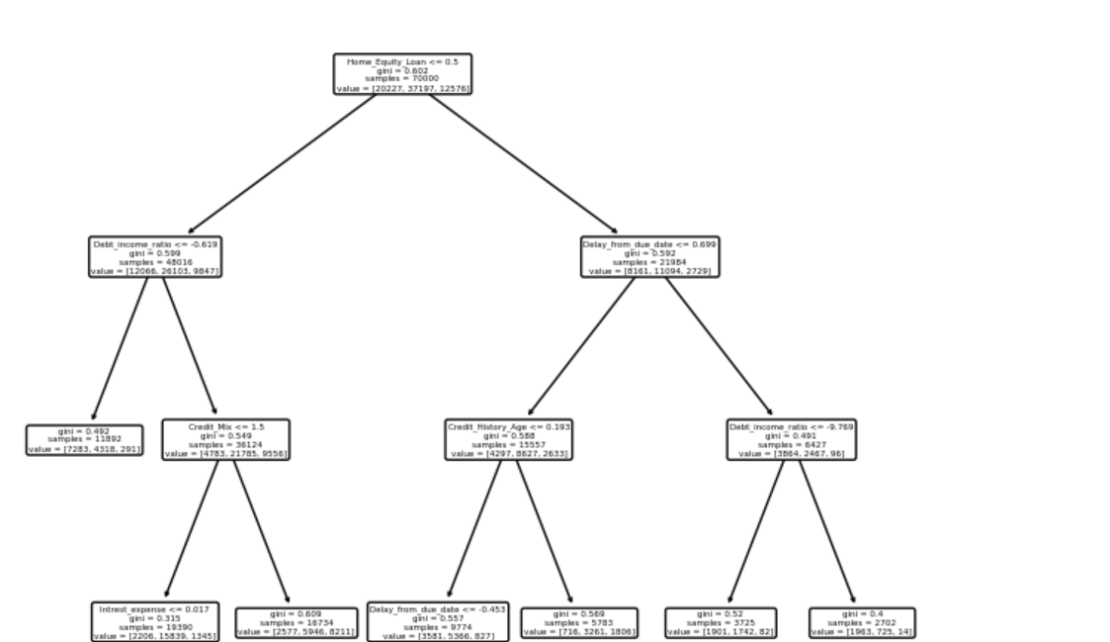

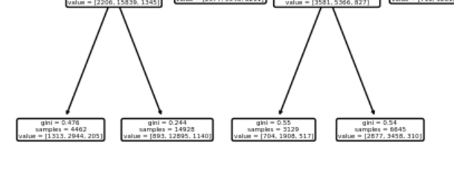

**Decision Tree Feature Importance after tuning**

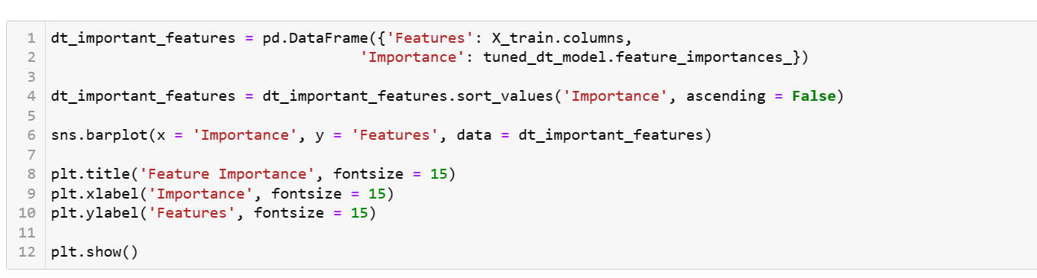

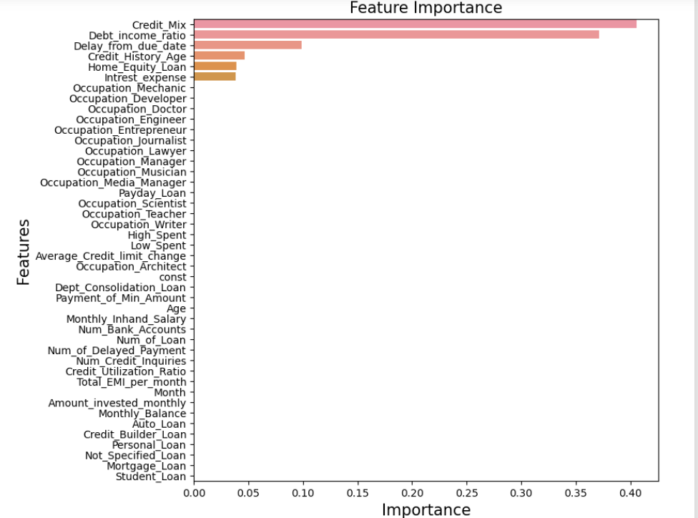

**Random Forest**

It is the method of constructing multiple decision trees on randomly selected data samples. We can use the bootstrap sampling method to select the random samples of the same size from the dataset to construct multiple trees. This method is used for both regression and classification analysis. The random forest returns the prediction based on all the individual decision trees prediction. For regression, it returns the average of all the predicted values; and for classification, it returns the class, which is the mode of all the predicted classes.

It avoids the over-fitting problem as it considers a random data sample to construct a decision tree.

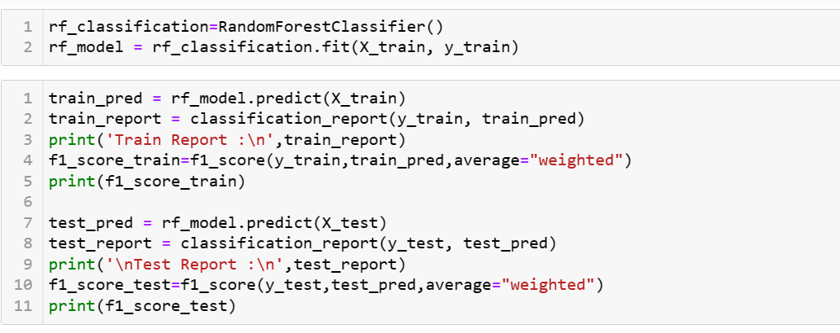

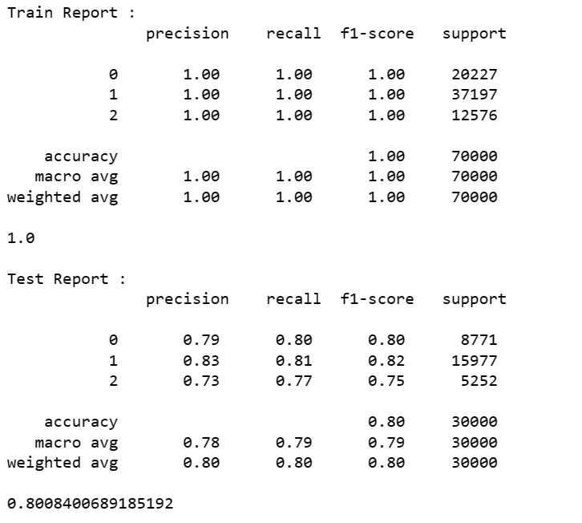

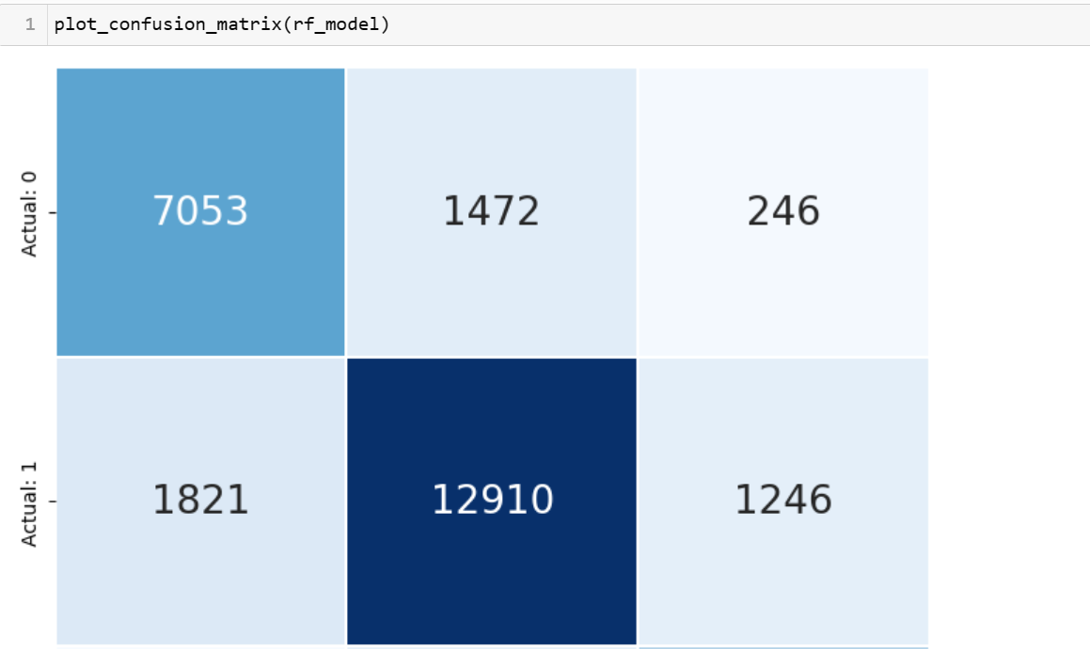

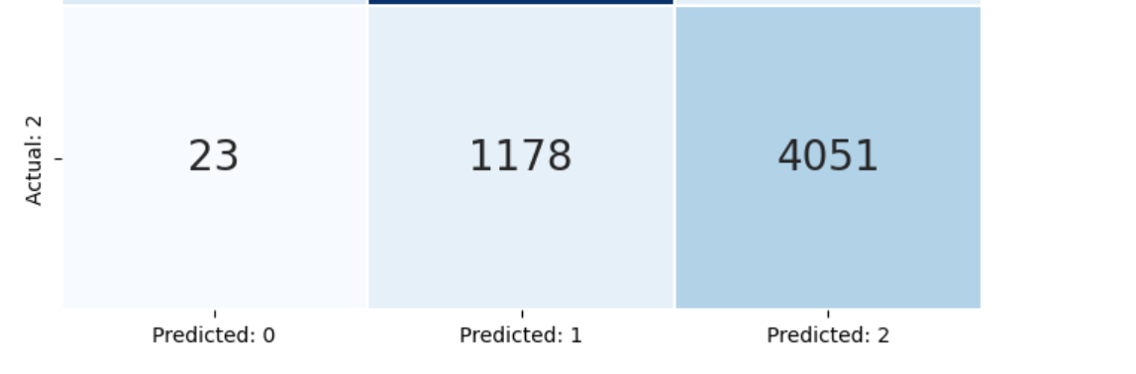

**Random Forest With Bagging Classifier**

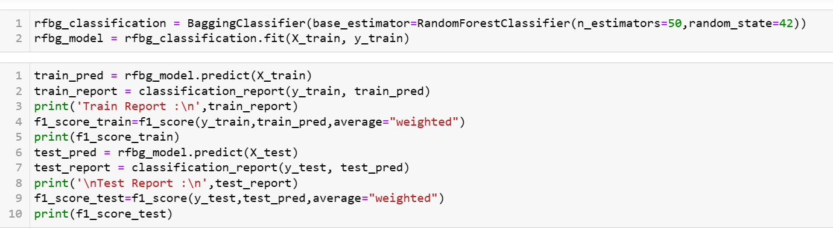

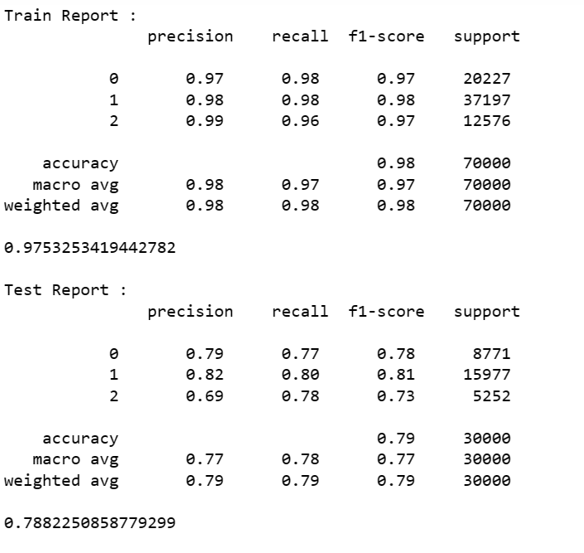

**Random Forest Feature Importance**

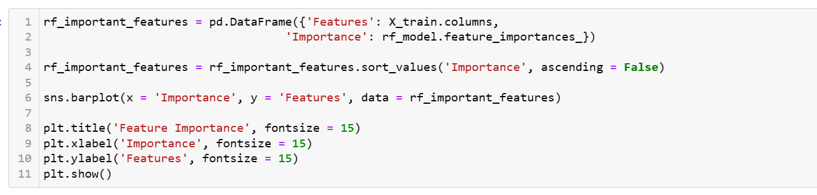

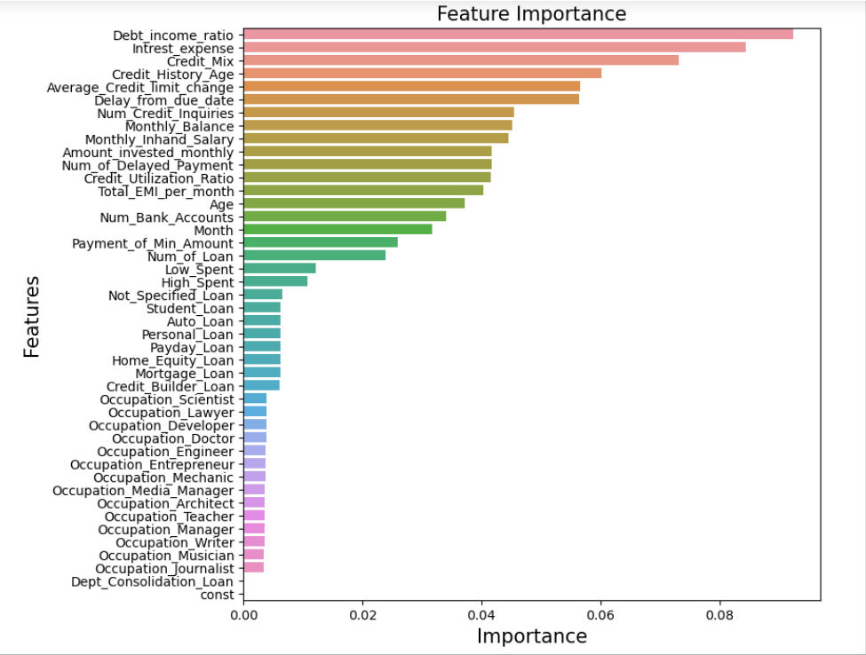

**Tuned Random Forest using Grid Search CV**

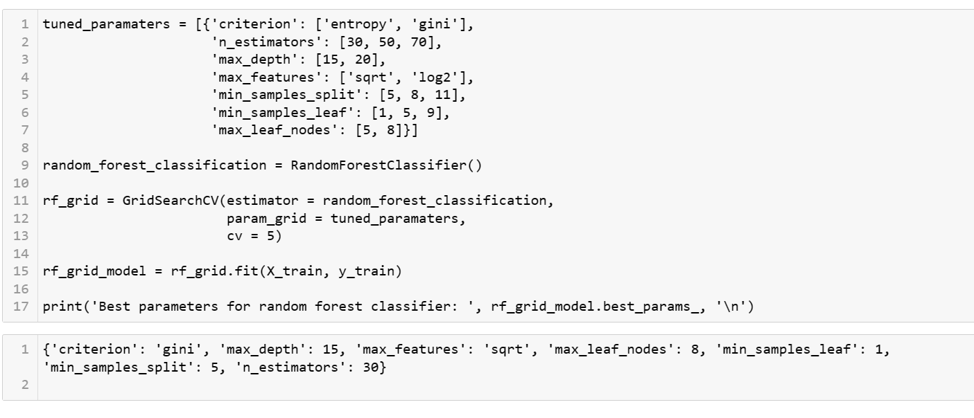

**Random Forest with Best Parameters**

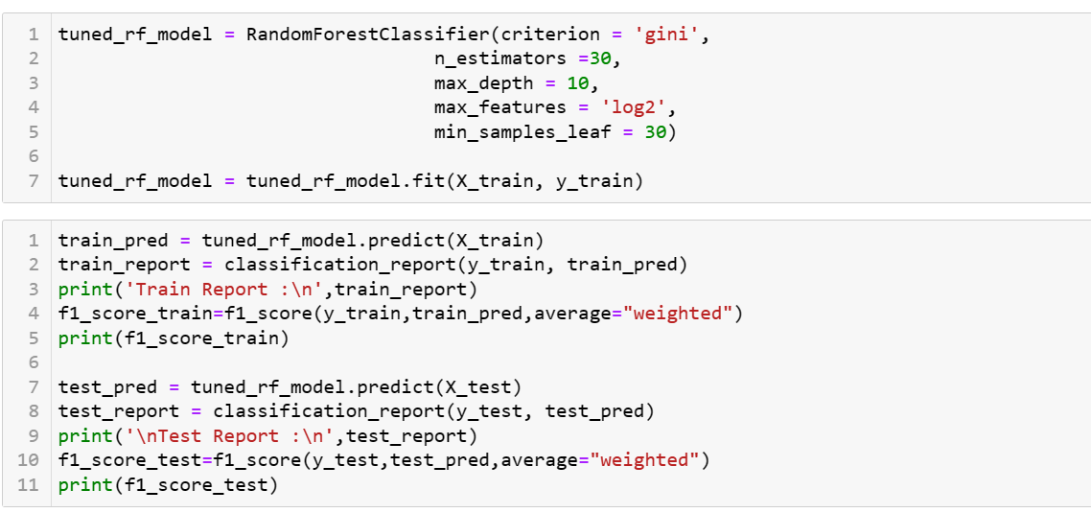

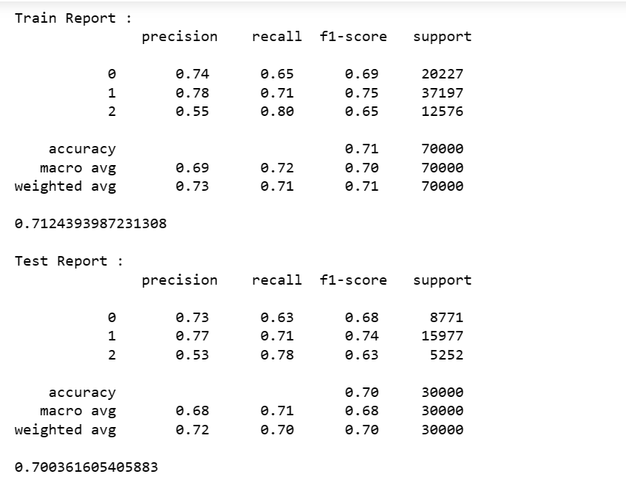

**Feature Importance For Tuned Random Forest**

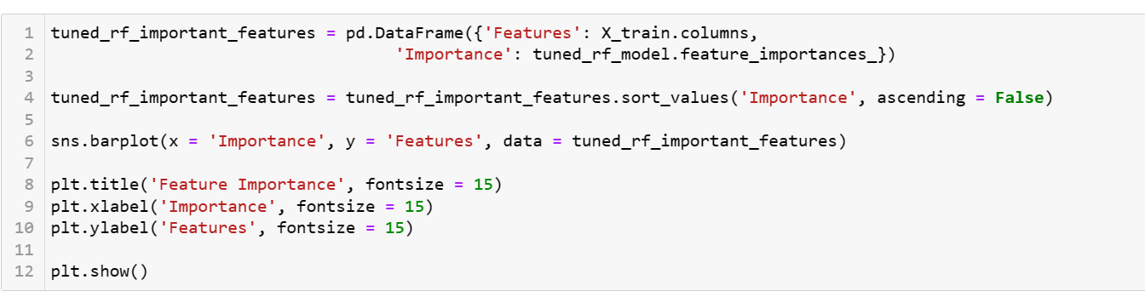

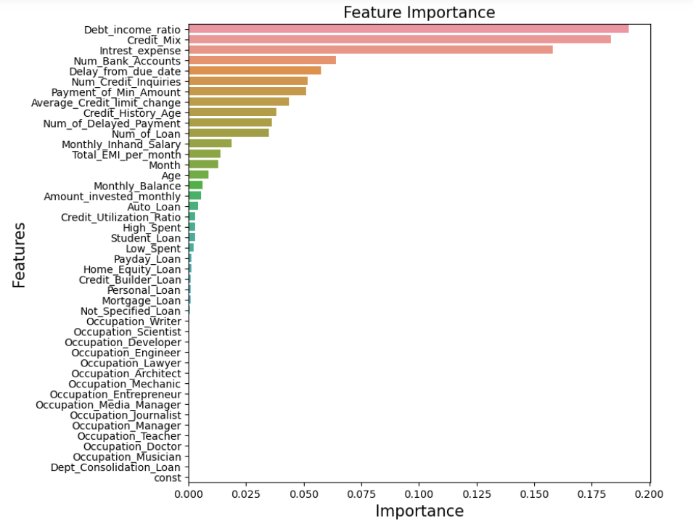

**GradientBoost**

This method optimizes the differentiable loss function by building the number of weak learners (decision trees) sequentially. It considers the residuals from the previous model and fits the next model to the residuals. The algorithm uses a gradient descent method to minimize the error.

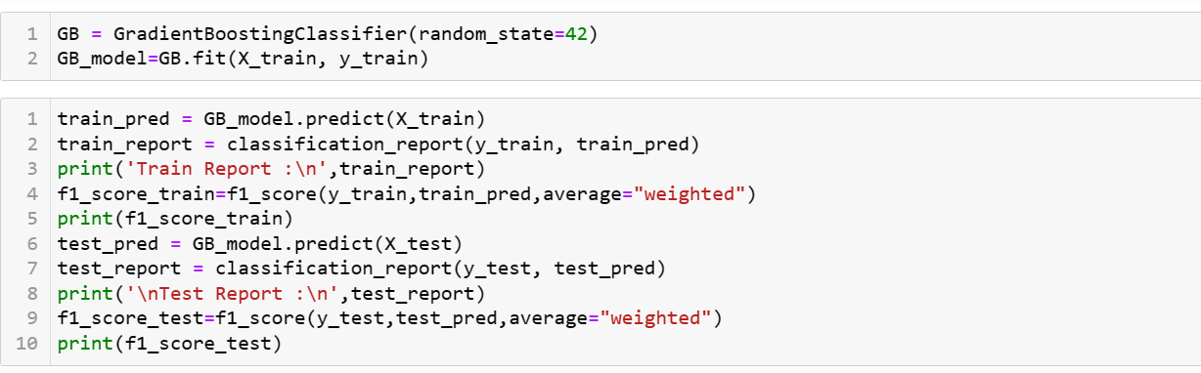

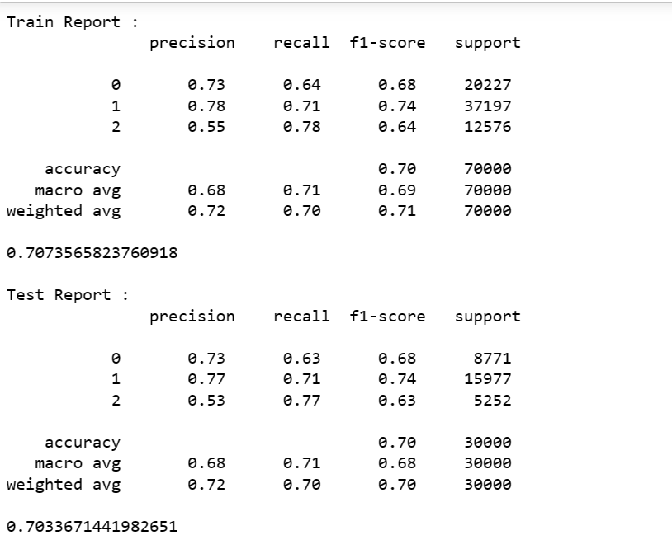

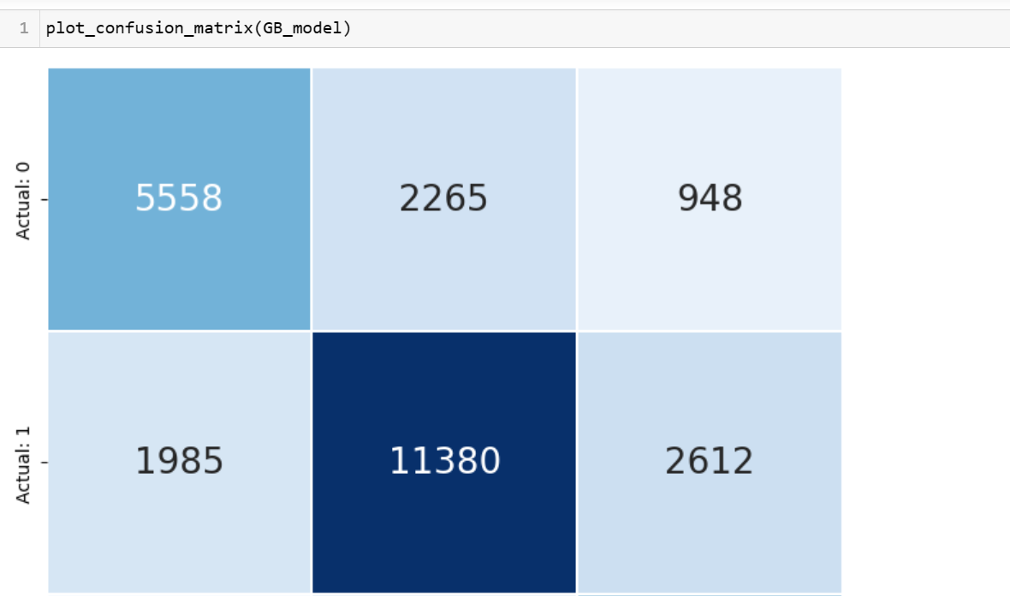

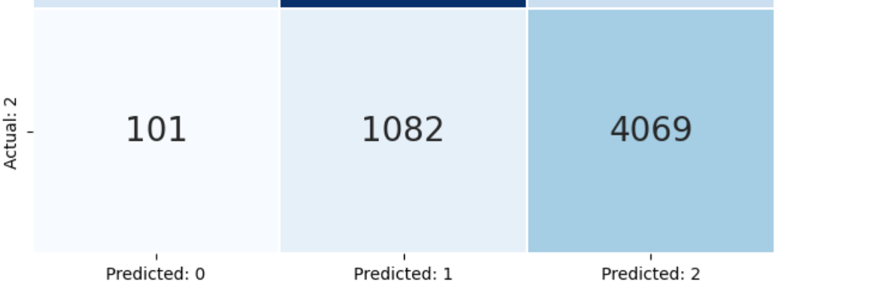

**Interpretation:**

Class 0 has a precision of 0.73, indicating that out of all the samples predicted as class 0, 73% of them are actually class 0. The recall for class 0 is 0.63, indicating that out of all the actual class 0 samples,the model correctly predicted 63% of them.

Class 1 has a precision of 0.77, indicating that out of all the samples predicted as class 1, 77% of them are actually class 1. The recall for class 1 is 0.71, indicating that out of all the actual class 1 samples, the model correctly predicted 71% of them.

Class 2 has a precision of 0.53, indicating that out of all the samples predicted as class 2, 53% of them are actually class 2. The recall for class 2 is 0.77, indicating that out of all the actual class 2 samples,the model correctly predicted 77% of them.

F1 score is 0.70 and Overall, the model has an accuracy of 0.70

**Gradient Boost Feature Importance**

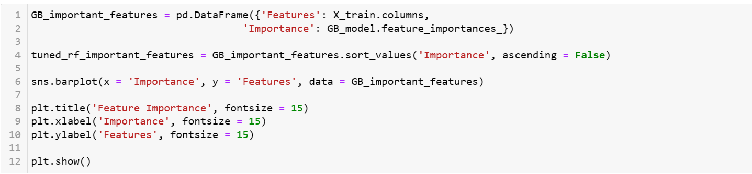

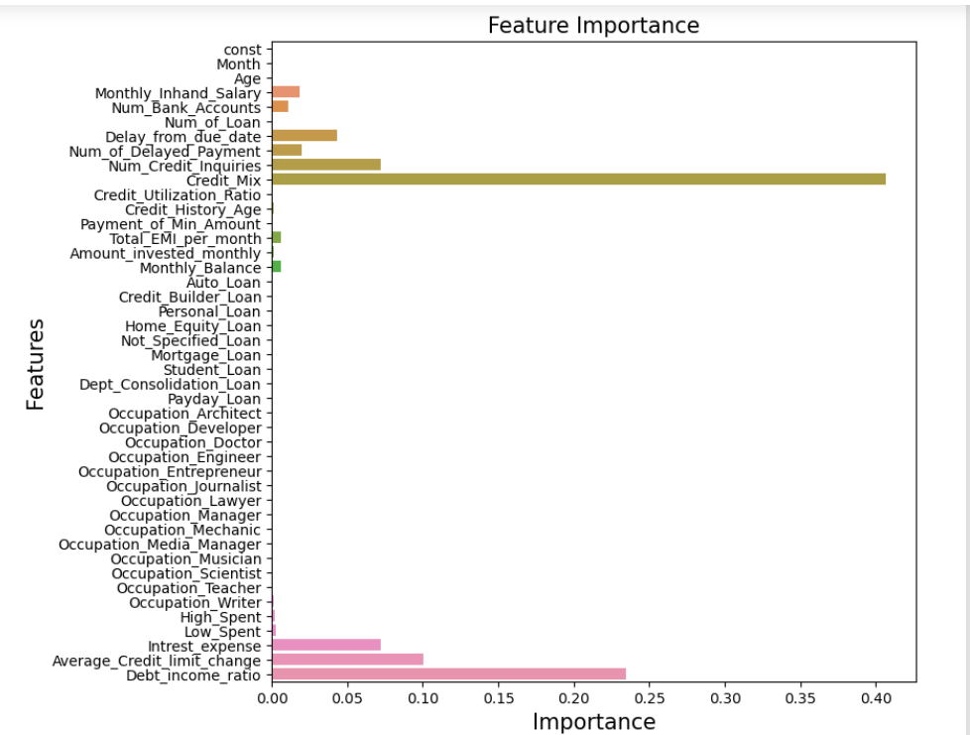

**XGBoost**

XGBoost (extreme gradient boost) is an alternative form of gradient boosting method. This method generally considers the initial prediction as 0.5 and build the decision tree to predict the residuals. It considers the regularization parameter to avoid overfitting.

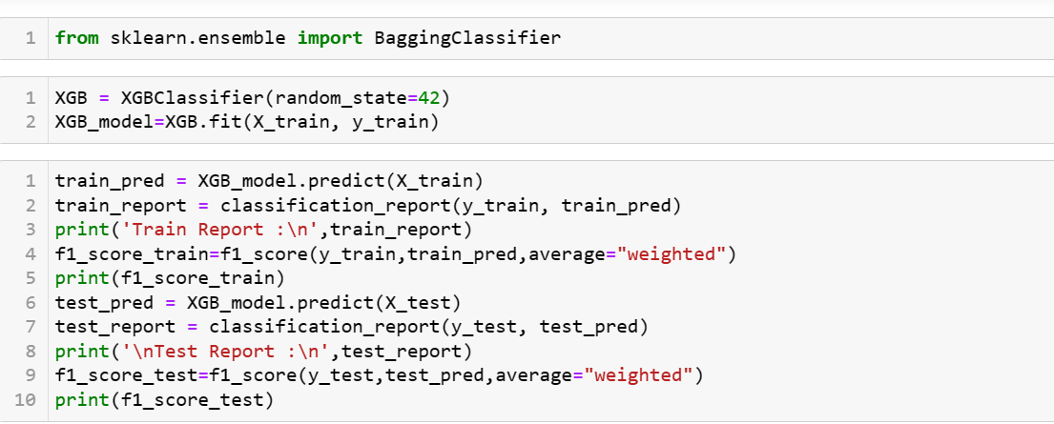

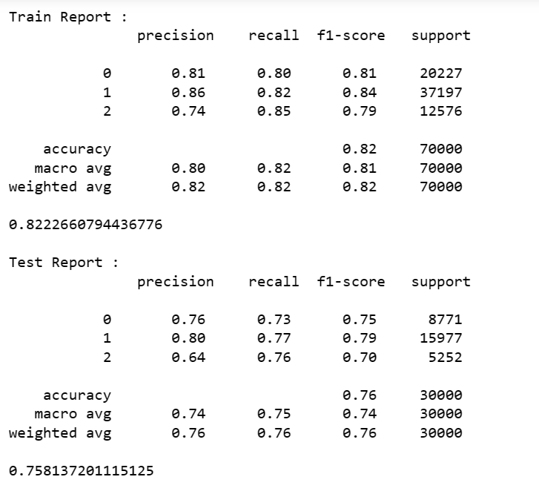

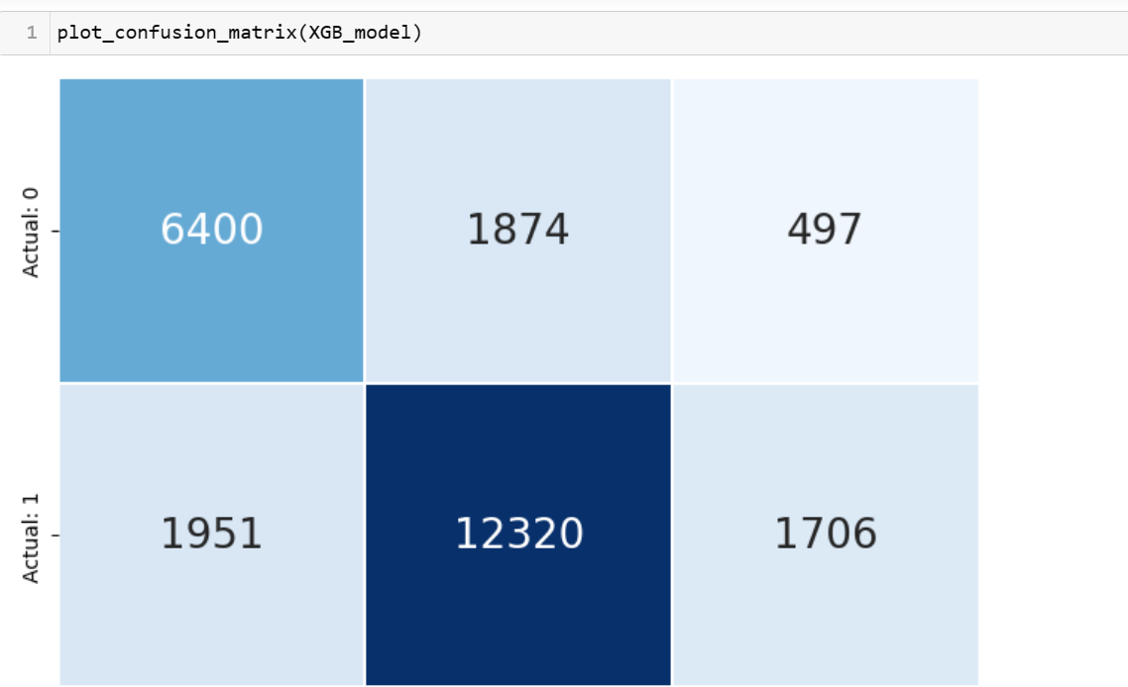

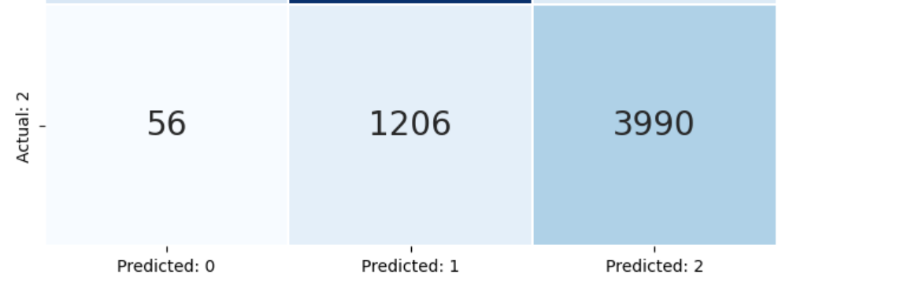

**Interpretation:**

Class 0 has a precision of 0.76, indicating that out of all the samples predicted as class 0, 76% of them are actually class 0. The recall for class 0 is 0.73, indicating that out of all the actual class 0 samples,the model correctly predicted 73% of them.

Class 1 has a precision of 0.86, indicating that out of all the samples predicted as class 1, 86% of them are actually class 1. The recall for class 1 is 0.82, indicating that out of all the actual class 1 samples, the model correctly predicted 82% of them.

Class 2 has a precision of 0.74, indicating that out of all the samples predicted as class 2, 74% of them are actually class 2. The recall for class 2 is 0.85, indicating that out of all the actual class 2 samples,the model correctly predicted 85% of them.

F1 score is 0.75 and Overall, the model has an accuracy of 0.75

**XGBoost Feature Importance**

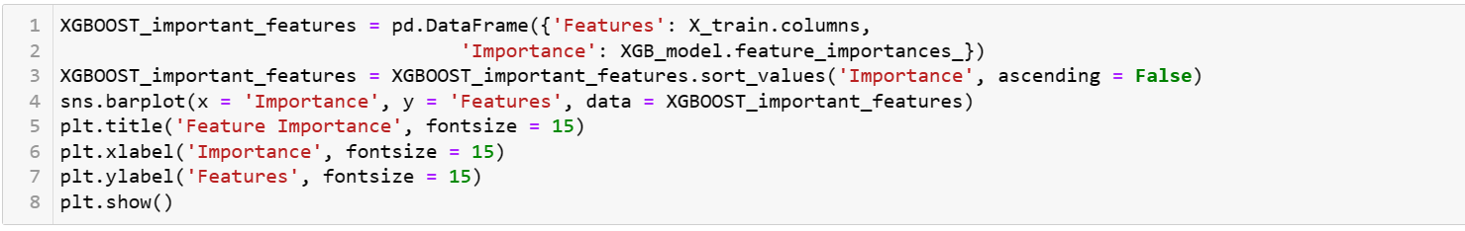

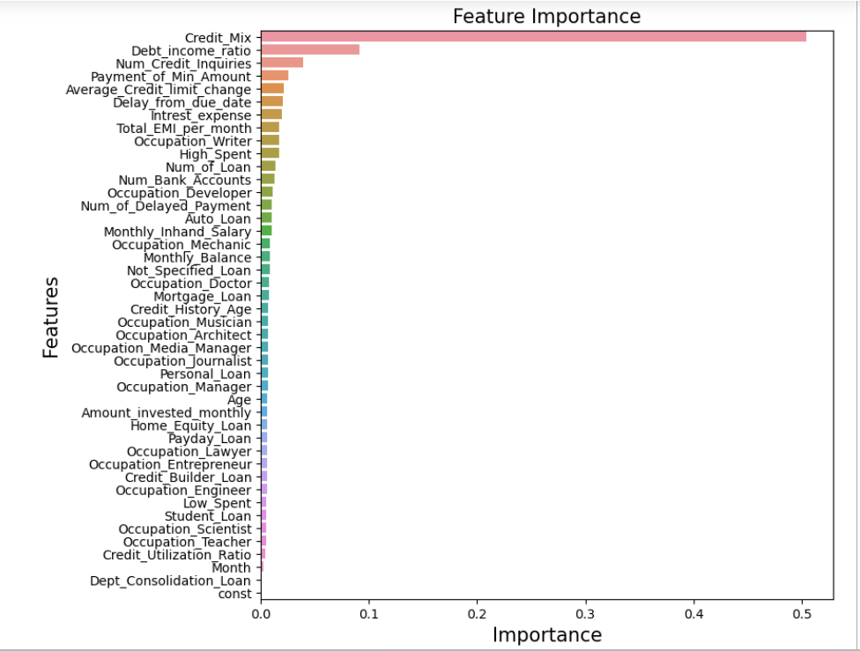

**XGBoost Tuning Parameters**

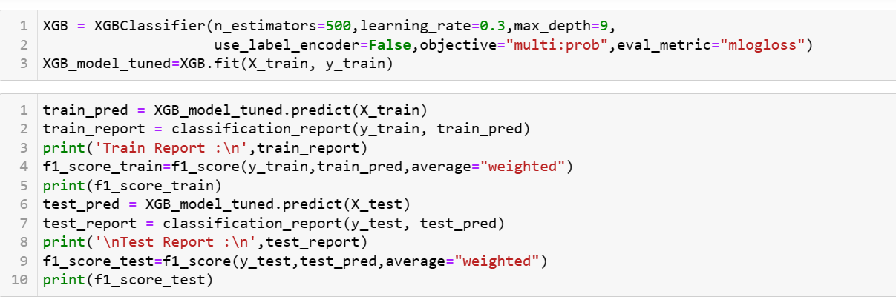

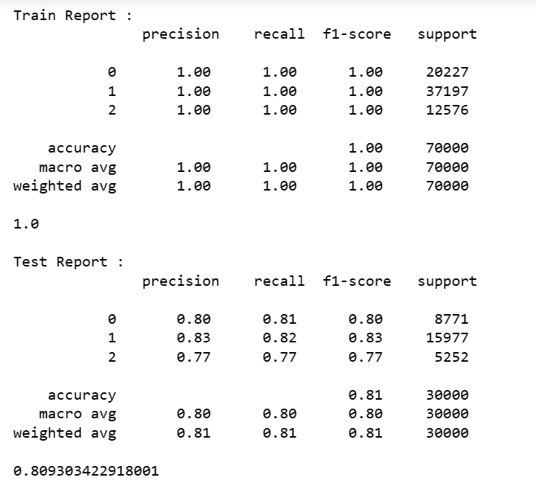

**Interpretation:**

Class 0 has a precision of 0.80, indicating that out of all the samples predicted as class 0, 80% of them are actually class 0. The recall for class 0 is 0.81, indicating that out of all the actual class 0 samples,the model correctly predicted 81% of them.

Class 1 has a precision of 0.83, indicating that out of all the samples predicted as class 1, 83% of them are actually class 1. The recall for class 1 is 0.82, indicating that out of all the actual class 1 samples, the model correctly predicted 82% of them.

Class 2 has a precision of 0.77, indicating that out of all the samples predicted as class 2, 77% of them are actually class 2. The recall for class 2 is 0.77, indicating that out of all the actual class 2 samples,the model correctly predicted 77% of them.

F1 score is 0.80 and Overall, the model has an accuracy of 0.81

**Voting Classifier**

A voting classifier is an ensemble machine learning technique where multiple base classifiers are trained to make predictions on a given dataset, and their predictions are combined using a voting mechanism to arrive at the final prediction. It is a popular technique in machine learning for improving the accuracy and robustness of predictions by leveraging the strengths of multiple classifiers.

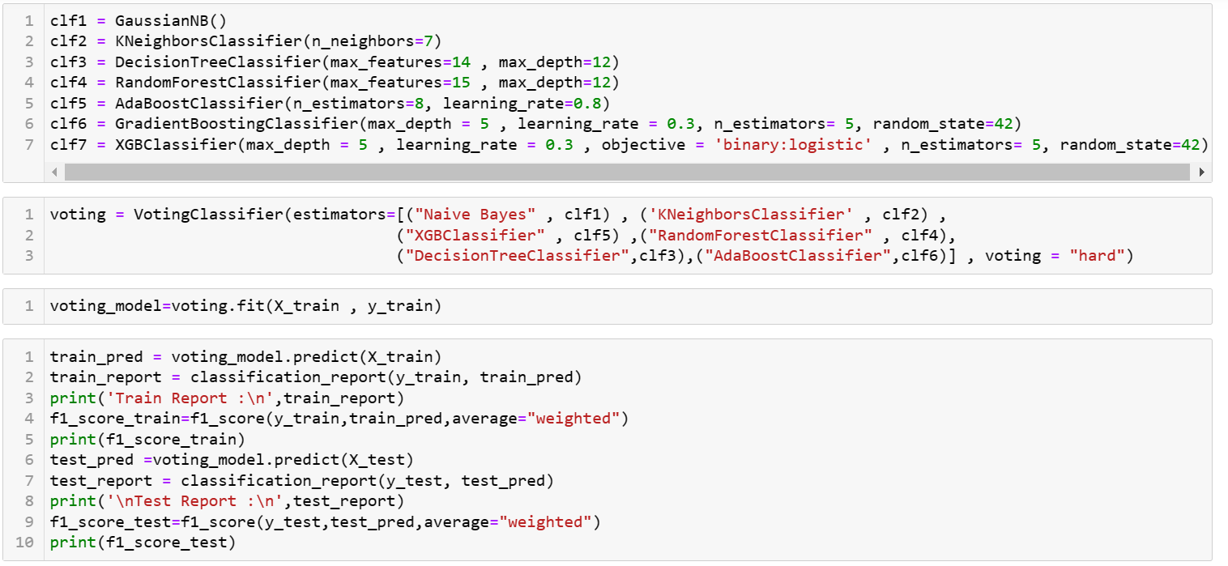

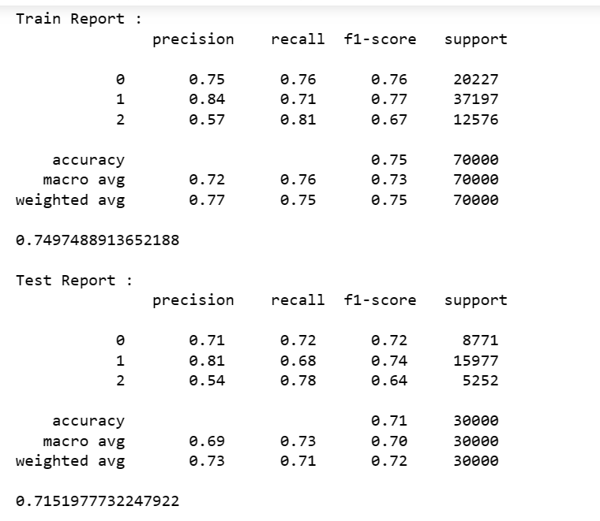

**Interpretation:**

Class 0 has a precision of 0.71, indicating that out of all the samples predicted as class 0, 71% of them are actually class 0. The recall for class 0 is 0.72, indicating that out of all the actual class 0 samples,the model correctly predicted 72% of them.

Class 1 has a precision of 0.81, indicating that out of all the samples predicted as class 1, 81% of them are actually class 1. The recall for class 1 is 0.68, indicating that out of all the actual class 1 samples, the model correctly predicted 68% of them.

Class 2 has a precision of 0.54, indicating that out of all the samples predicted as class 2, 54% of them are actually class 2. The recall for class 2 is 0.78, indicating that out of all the actual class 2 samples,the model correctly predicted 78% of them.

F1 score is 0.71 and Overall, the model has an accuracy of 0.71

**Validation Dataset**

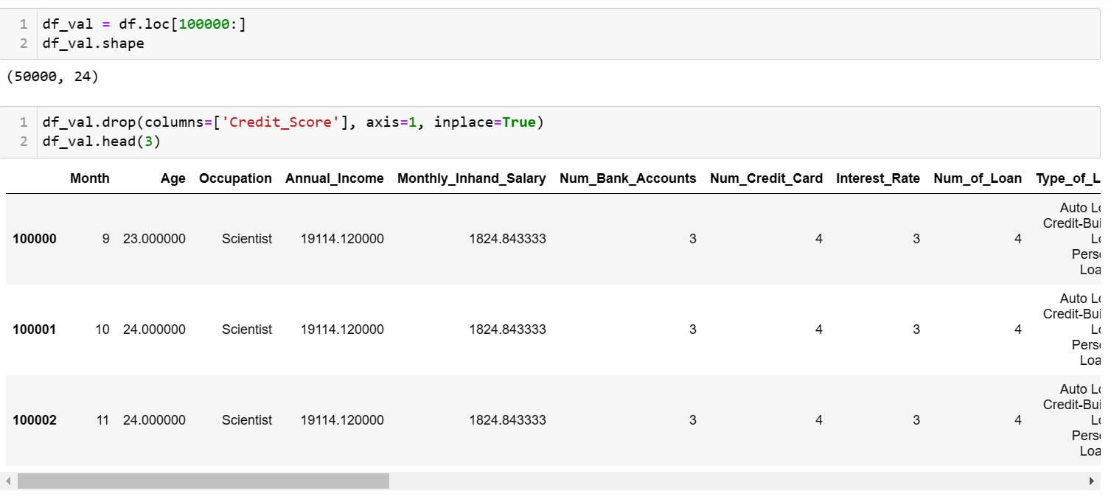

**Note :** Data Cleaning and others till EDA is done above in the Data cleaning section by combining both Train and Test data set

**Prediction using Random Forest**

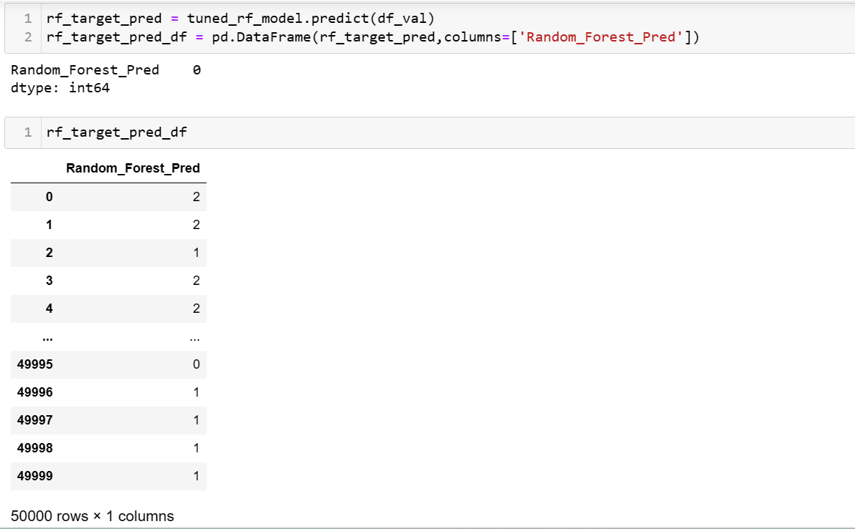

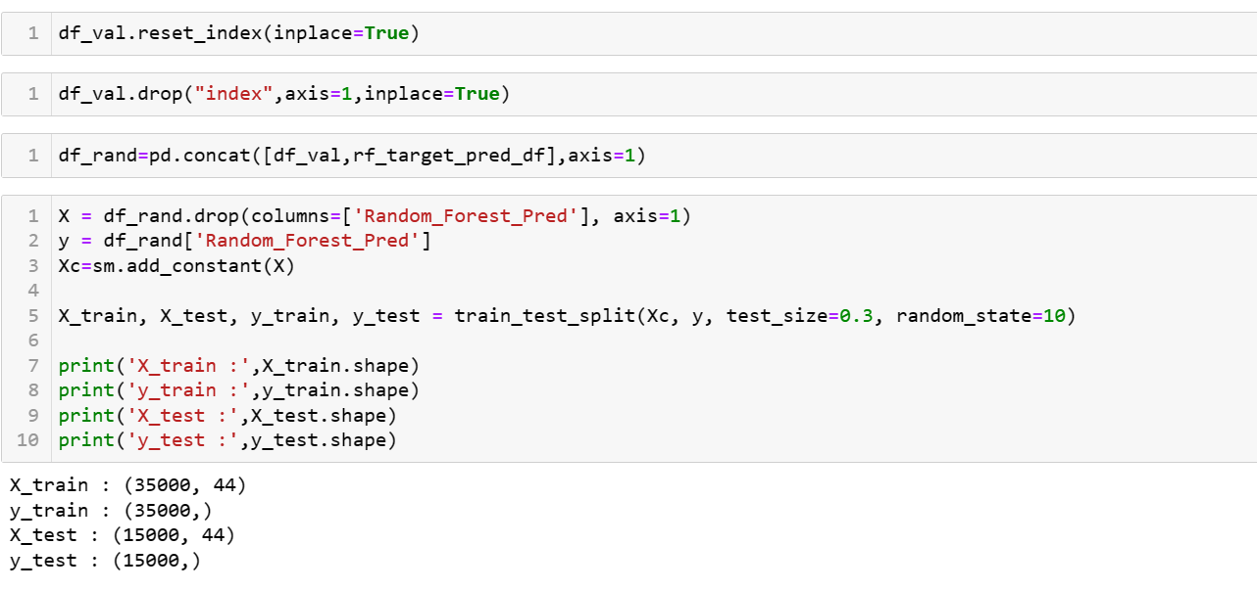

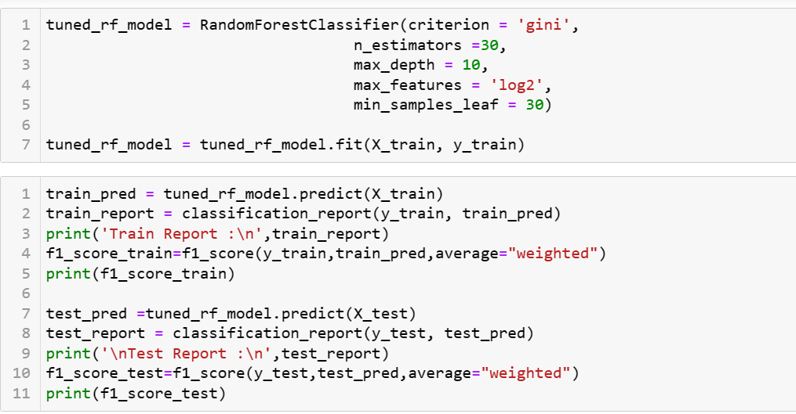

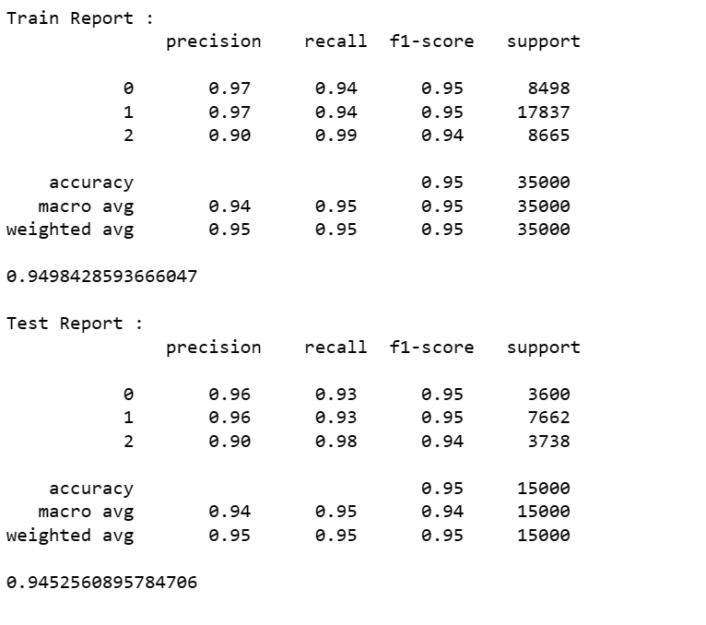

**Predicting using XGBoost**

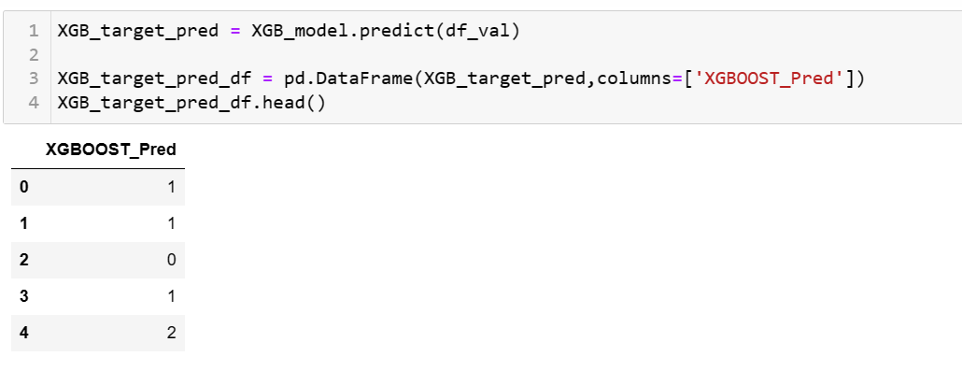



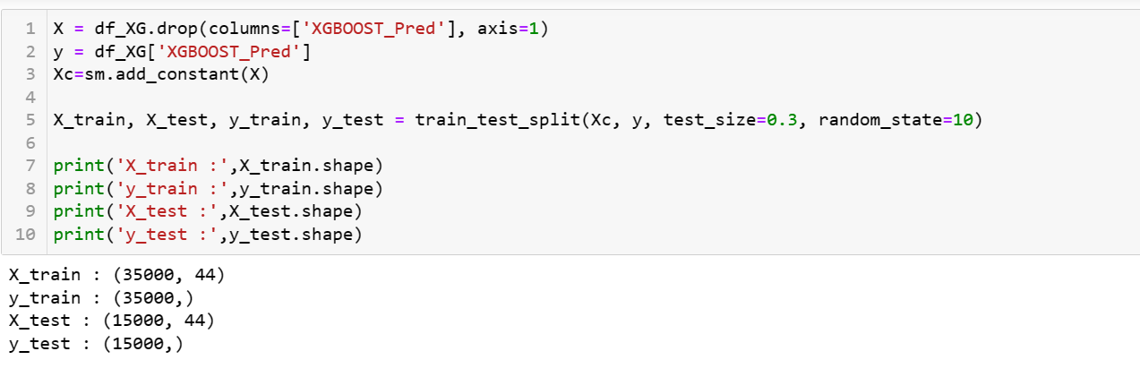

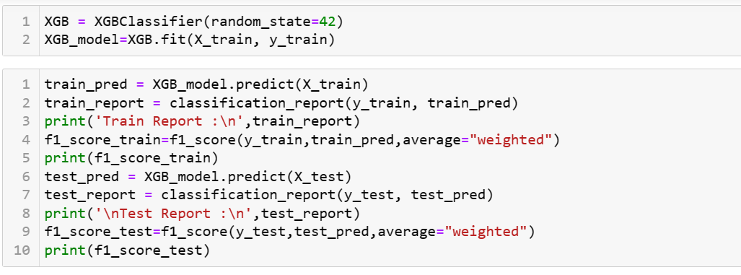

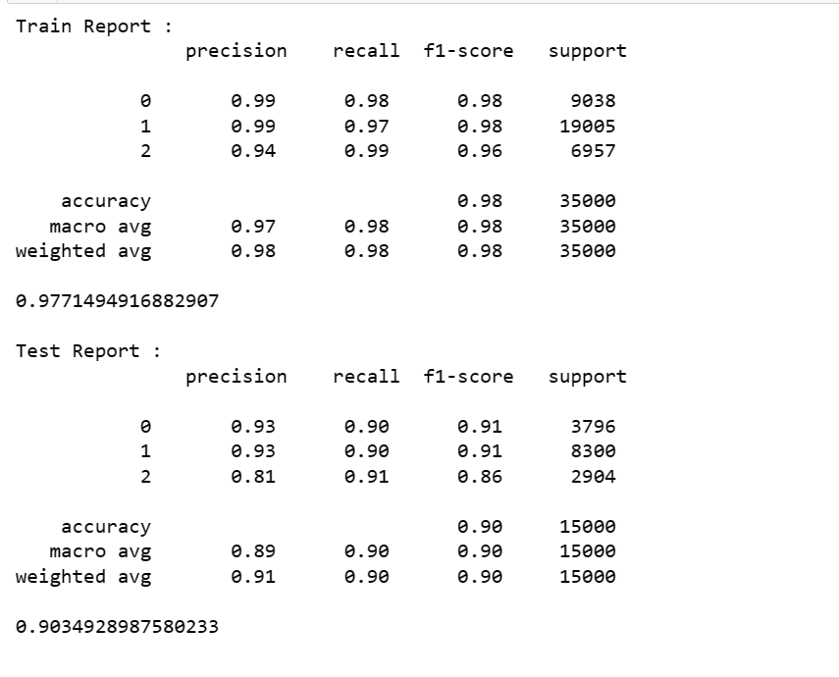

**Predicting using Voting Classifier**

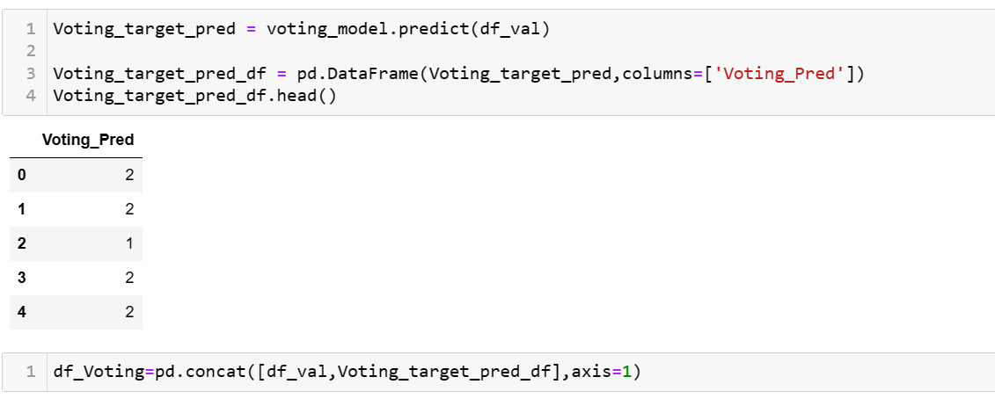

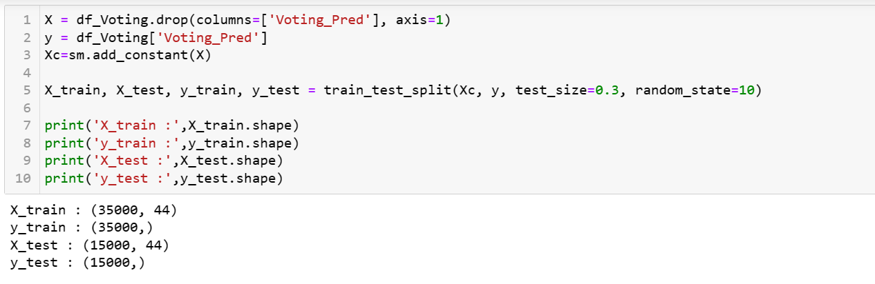

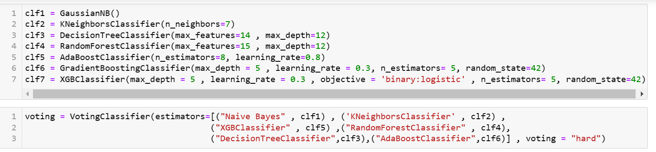

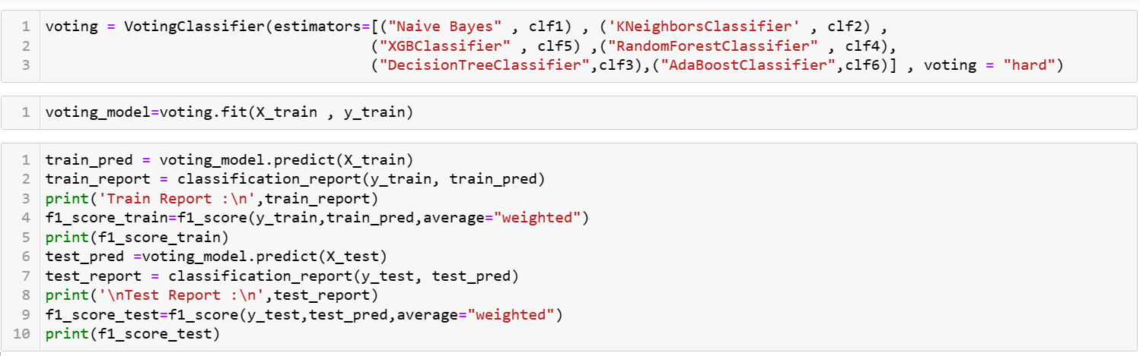

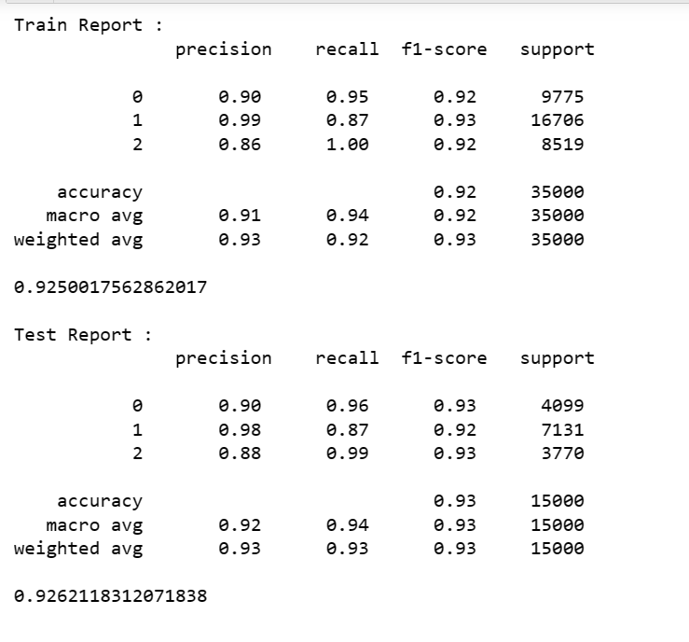

**Predicting using Gradient Boosting**

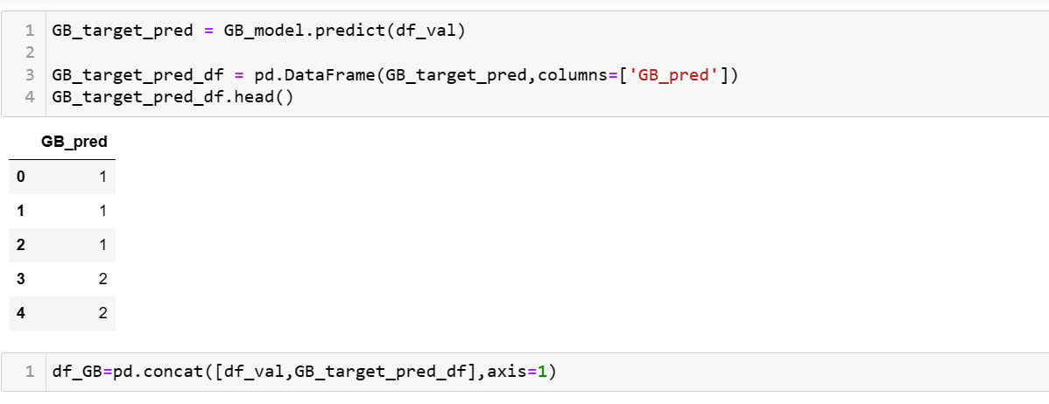

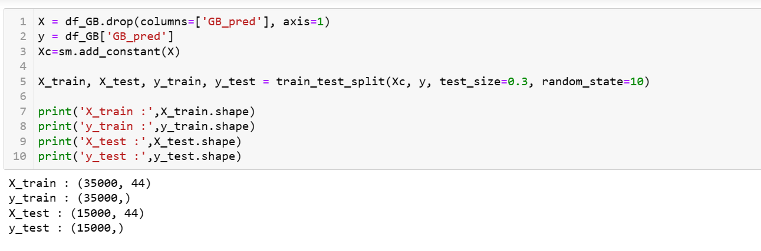

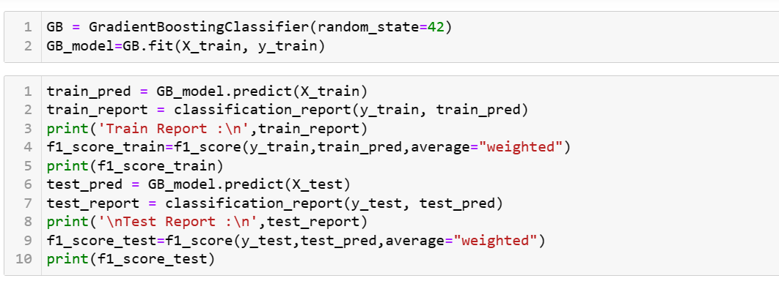

**Business Insight**

Identifying High-Risk Applicants: The credit score classification model can help identify applicants who are more likely to default on their loans. By flagging high-risk applicants, financial institutions can take appropriate measures such as offering higher interest rates or declining their loan applications altogether.

Improving Loan Approval Process: With the help of the credit score classification model, financial institutions can streamline their loan approval process. By automating the credit scoring process, financial institutions can reduce the time and cost involved in manual credit assessments, which can improve customer experience and operational efficiency.

Optimizing Credit Risk Management: By using the credit score classification model, financial institutions can optimize their credit risk management strategies. The model can help identify trends and patterns in credit risk, which can be used to develop more effective risk management policies and procedures.

Increasing Loan Portfolio Performance: By using the credit score classification model, financial institutions can improve the performance of their loan portfolios. By targeting applicants with a higher likelihood of repaying their loans, financial institutions can reduce their default rates and improve the overall performance of their loan portfolios.

Random Forest(best performing):

1. Significant Features(Before GridSearch CV): Credit_Mix, Interest_Rate, Outstanding_Debt, Payment_of_Min_Amount, Delay_from_due_date, Num_Bank_Accounts, Num_Credit_Inquiries, Credit_History_Age, Num_Credit_Card, Num_of_Loan, Num_of_Delayed_Payment, Changed_Credit_Limit, Annual_Income, Monthly_Inhand_Salary, Month, Age, Monthly_Balance, Mortgage_Loan, Auto_Loan, Total_EMI_per_month, Personal_Loan, Student_Loan, Low_Spent and High_Spent

2. Significant Features(After GridSearch CV): Credit_Mix, Interest_Rate, Outstanding_Debt, Payment_of_Min_Amount, Delay_from_due_date, Num_Bank_Accounts, Num_Credit_Inquiries, Credit_History_Age, Num_Credit_Card, Num_of_Loan, Num_of_Delayed_Payment, Changed_Credit_Limit, Annual_Income, Monthly_Inhand_Salary, Month, Age, Monthly_Balance, Mortgage_Loan, Auto_Loan, Total_EMI_per_month, Personal_Loan, Student_Loan, Low_Spent,and High_Spent.

**Limitations:**

**Random Forest**

Interpretability: Random forests are not as interpretable as single decision trees. It can be challenging to understand how the model arrived at its predictions, especially when there are many trees in the forest.

Overfitting: Although random forests are designed to reduce overfitting compared to individual decision trees, they can still overfit if the number of trees is too high or if the trees are too complex.

Computationally Expensive: Random forests require significant computational resources to train and evaluate, especially when there are many trees and large datasets.

Biased towards features with many levels: Random forest tends to favor features with many levels or categories, as they tend to create more splits in the decision trees.

Out-of-bag samples may not be representative: Random forests use a bootstrap sampling method to train each tree, and the out-of-bag samples are used to estimate the generalization error. However, the out-of-bag samples may not be representative of the entire dataset, especially if the dataset is imbalanced.

Difficulty in handling missing values: Random forests cannot handle missing values in the input data. Therefore, missing values must be imputed before training the model.

**Voting Classifier**

Overfitting: The voting classifier can overfit if the individual models are overfitting or if the combination of models is not well balanced. Careful selection of the individual models and the combination approach is necessary to prevent overfitting.

Diversity of Models: The voting classifier performs better when the individual models are diverse. If the individual models are too similar, the voting classifier may not improve performance over a single model.

Complexity: The complexity of the voting classifier increases with the number of models included in the ensemble. Therefore, the computational resources required to train and evaluate the model can increase significantly.

Interpretability: The voting classifier is not easily interpretable, and it can be challenging to understand how the model arrived at its predictions, especially when many models are used.

Model Selection: The selection of individual models for the voting classifier is crucial for achieving good performance. The process of selecting models and their hyperparameters can be time-consuming and require significant computational resources.

Imbalanced Classes: The voting classifier can be biased towards the majority class if the classes are imbalanced. Careful selection of the combination approach and the individual models is necessary to prevent bias towards the majority class.

**Gradient Boosting**

Computationally Expensive: Gradient boosting requires significant computational resources to train and evaluate, especially when there are many features and large datasets. The training time and memory usage can be a challenge for complex models and large datasets.

Hyperparameter Tuning: Gradient boosting has many hyperparameters, and choosing the optimal set of hyperparameters can be challenging. The tuning process can be time-consuming and require significant computational resources.

Overfitting: Gradient boosting can overfit if the number of trees is too high, or if the maximum depth of the trees is too large. Careful selection of hyperparameters and early stopping can help prevent overfitting.

Difficulty in handling missing values: Gradient boosting cannot handle missing values in the input data. Therefore, missing values must be imputed before training the model.

Interpretability: Gradient boosting is a complex algorithm that is not easily interpretable. It can be challenging to understand how the model arrived at its predictions, especially when there are many trees and features.

Bias towards features with many levels: Gradient boosting tends to favor features with many levels or categories, as they tend to create more splits in the decision trees. This bias can lead to suboptimal performance for datasets with features with few levels or categories.

Sensitivity to Outliers: Gradient boosting is sensitive to outliers in the input data. Outliers can have a significant impact on the decision boundaries created by the trees in the model, leading to suboptimal performance.

Gradient Boosting is prone to overfitting if the dataset has a large number of noisy features that are irrelevant to the outcome. In such cases, feature selection or feature engineering is necessary to improve performance.

**Conclusion**

The credit score classification dataset is a valuable resource for building models to predict the creditworthiness of applicants. The dataset includes information on various attributes such as age, income, credit history, and other financial indicators that can help predict the likelihood of an applicant to repay their debts.

Several machine learning algorithms, such as logistic regression, decision trees, random forests, gradient boosting, and support vector machines, can be used to build models for this dataset. The performance of these models can be evaluated using metrics such as accuracy, precision, recall, F1-score, and AUC-ROC curve.

However, it is important to note that building models for credit score classification requires careful consideration of ethical and legal issues, such as fairness, bias, and privacy concerns. It is crucial to ensure that the models do not discriminate against certain groups of applicants based on protected characteristics such as race, gender, and age.

Overall, the credit score classification dataset provides a valuable opportunity to develop models that can improve credit risk assessment and support informed decision-making in the financial industry.

**Reference**

Naive Bayes: Reference: Rish, I. (2001). An empirical study of the naive Bayes classifier. IJCAI 2001 workshop on empirical methods in artificial intelligence, 41-46.

Decision Trees:Reference: Quinlan, J. R. (1986). Induction of decision trees. Machine learning, 1(1), 81-106.

Random Forest:Reference: Breiman, L. (2001). Random forests. Machine learning, 45(1), 5-32.

Support Vector Machines:Reference: Cortes, C., & Vapnik, V. (1995). Support-vector networks. Machine learning, 20(3), 273-297.

K-Nearest Neighbors:Reference: Cover, T., & Hart, P. (1967). Nearest neighbor pattern classification. IEEE Transactions on information theory, 13(1), 21-27.

Gradient Boosting:Reference: Friedman, J. H. (2001). Greedy function approximation: A gradient boosting machine. Annals of statistics, 29(5), 1189-1232.

Chen, T., & Guestrin, C. (2016). XGBoost: A scalable tree boosting system. In Proceedings of the 22nd ACM SIGKDD International Conference on Knowledge Discovery and Data Mining (pp. 785-794). ACM.

Freund, Y., & Schapire, R. E. (1996). Experiments with a new boosting algorithm. In Proceedings of the 13th International Conference on Machine Learning (pp. 148-156). Morgan Kaufmann.